AWARENESS IMPROVEMENT AND LOCAL PEOPLE INVOLVING INTO RARE BIRDS CONSERVATION
VIA BIRDWATCHING WEBSITES NETWORK DEVELOPMENT

Isabekov A.
Almaty, Kazakhstan
askarisabekov@birds.kz

Abstract: Birds of Kazakhstan (birds.kz) – the first site of the network – was launched in 2005. Now it contains more than 150 000 photos of 483 species of birds. Participants of project found 17 new species of birds in Kazakhstan. Since 2015, based on the same framework, we developed and launched websites for other countries of Central Asia and Caucasus, and also for some regions of Russia and China. Participation in the project is free. The total number of members registered in the network is more than 1000. Many students and teachers use the data from the network in the process of education. Some global and all local ecology organizations use the network database in researches, especially in researches of rare birds and exploring of the species areas.

Keywords: birds, birdwatching, website, network, awareness, education

The Birdwatching Websites Network project covers all species of birds, including rare and protected species. Currently website birds.kz contains facts about 93% of all birds’ species of Kazakhstan, including all Red Data book species of birds. Database of the website contains about 167000 photos of 483 birds’ species. Participants of the project found 17 new species of birds for Kazakhstan, and also found new breeding sites (example, White-headed Duck), registered some important records, such as the first evidence of breeding in the territory of Kazakhstan (Altai Snowcock).
The main goal of the project is to promote birdwatching on the new level in the countries where it was not popular previously. Some people of these countries use our websites as online-guides, other as platform for communication. Websites provide the opportunity to communicate for people sharing the same hobby, which are very few yet. However, we believe that the number of birdwatchers will increase and the sites are the main instrument in this process. One of the most common ways of coming into birdwatching is following: somebody take a photo of a bird, then he wants find out the name of this bird on the internet, when looking for the information he finds a local website, and finally becomes a participant of the project.

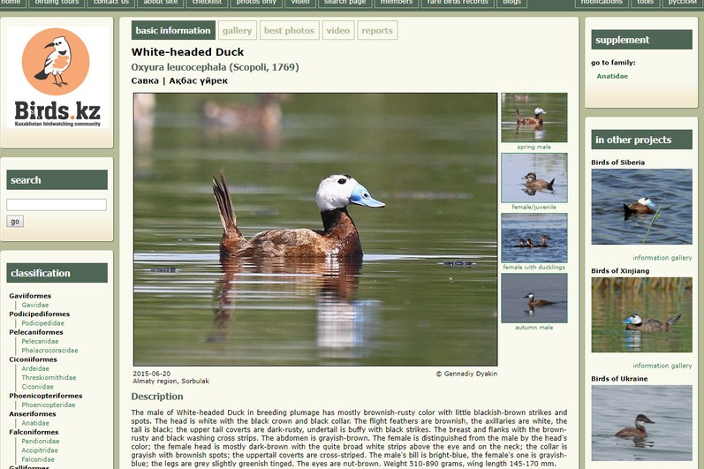
Fig. 1. White-headed Duck page on birds.kz

An average participant is a middle-aged person. These people are the main generators of information. The users of the network which are not generating information are students and teachers of middle and high schools. This group of participants uses facts of the websites either in their essays (students) or in classes and lectures (teachers). Students and teachers form the large (about 30%) part of visitors of the websites.
Special mention should be made about using facts, photos and records from the sites of the project by professional ornithologists, ecologists, and publishers. Bird records data, photos, records collected on the sites were many times used in articles, researches, books, and for monitoring rare and common species birds. As example the last book “Birds of deserts of Kazakhstan” by Gubin B.M., “Handbook of Western Palearctic Birds” by Hadoram Shirinhai and Lars Svensson, annual monitoring of wintering Waterfowl. Staff members of local ecology organizations monitor records of rare birds at the website (example, White-headed Duck).
We have producers of the facts and users of these facts. The task of the network is to increase the number of producers and to create comfortable interface for the users, in particular, we plan to make some options for comfortable access to databases of the project.
Local birdwatchers are the main beneficiaries from the developing of the project. Ecologists, scientist, nature protectors are secondary but quite significant beneficiaries.
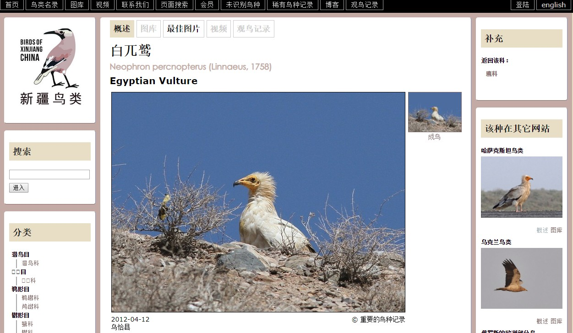
Local websites of the project can contribute to the cohesion of communities and became now almost the best place for communication and groups meeting through common interest. Each local website produces information almost only by efforts of the local people, and mostly local people are the users of the site (teachers, students, ecologists, scientists, and birdwatchers, of course). Foreigners produce less than 1% of total information of site. Moderators, administrators, bird’s id experts are also only local people.
Fig. 2. Egyptian Vulture page on Xinjiang website

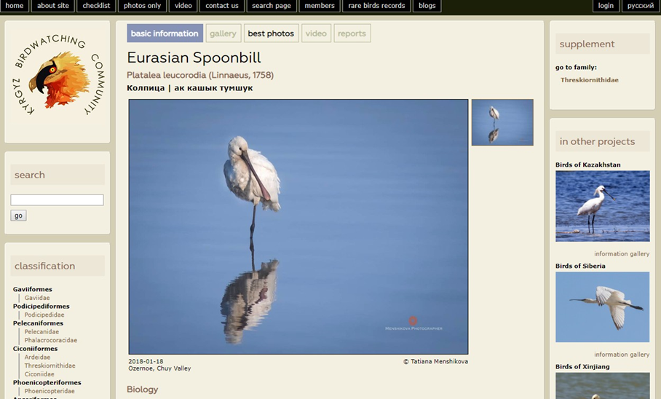
Birds of Kazakhstan (birds.kz) – the first site of the network – was launched in 2005. In 2015 new site engine was applied and three new websites were created (Siberia, Ukraine, Xinjiang). In 2018 new local websites for Kyrgyzstan, Uzbekistan and Tajikistan were launched.
Fig. 3. Eurasian Spoonbill page on the Kyrgyzstan website

Currently the hierarchical site system developed, which allows us to create supersites and subsites. The example of this idea is the site of the birds of Tyumen region (http://tyumen.birds.watch), which is the also site of lower level to site “Birds of Siberia” (http://sibrids.ru).
The small local communities develop more quickly than big ones. All together they can generate increasing of traffic, and by some point generate incomes too. In local communities, especially in formalized ones the process of forming of leader is simpler than in large groups. The leaders of small local communities could be partners in different actions, including financial support of main project. Creating of 10-15 local communities on city/province level is a plan for the next years. One of the results of this plan is to make the project self-sustainable.
In order to improve public awareness for bird conservation among young people, we plan to make exhibitions in the schools of rural district centers. In these exhibitions we want to display photos of birds including rare and protected species in their natural environment. The long-time exhibitions are one of the simplest and most available modes of education, much better than short-term actions.
At the time of opening of the exhibitions our activists will provide open lessons about the importance of birds and their habitats to maintain a healthy environment, to address present threats to the avifauna of Kazakhstan, their causes and solutions as far as possible, to motivate local youth join birdwatching and conservation activities.
Another objective of the open lessons is to establish bird monitoring groups to take part in the weekly bird monitoring around their schools. It will be shown to students how to observe birds and make records of birds’ behavior. They also will be encouraged to communicate with their group-mates and their families about their bird sightings and to provide the collected information to our web database.

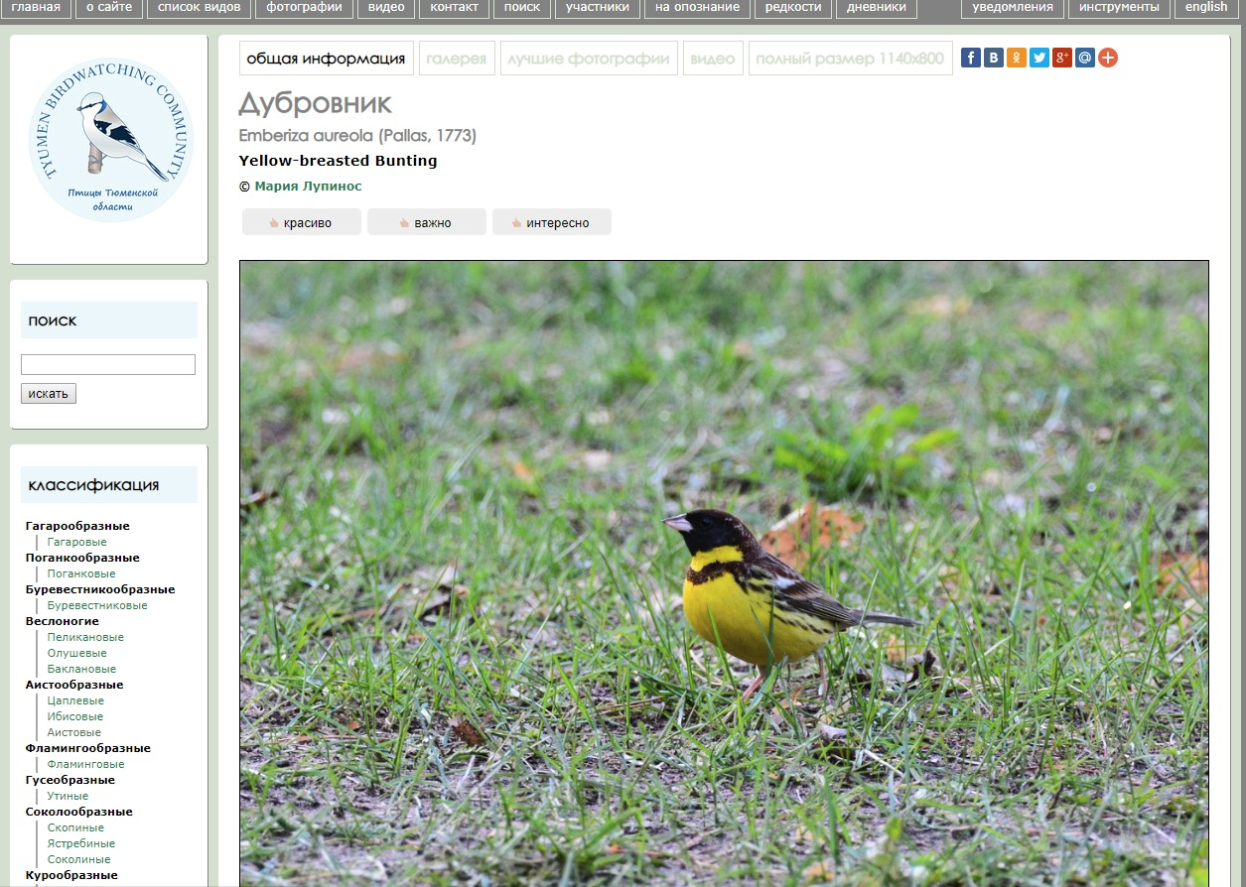
Fig. 4. Yellow-breasted Bunting page on Tyumen region website

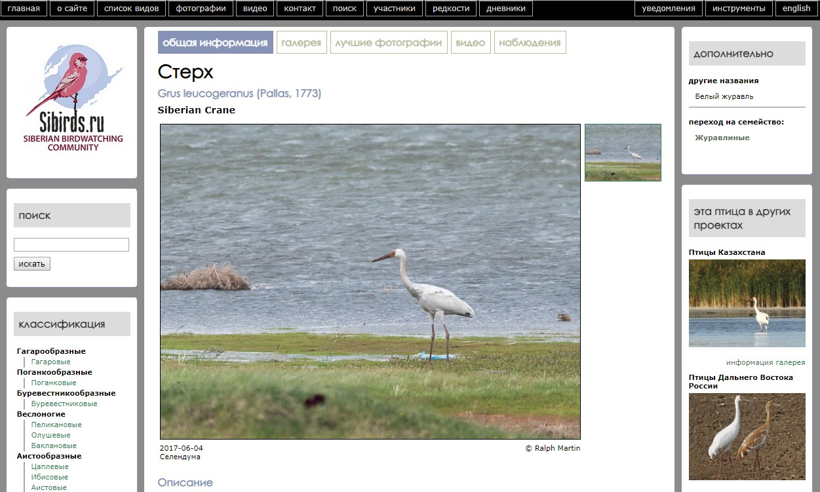
Fig. 5. Siberian Crane page on Siberian website

