MINIMUM OFFER 250MT!

HOT OFFER of AFRICA

STOCK:
TYPE | SCIENTIFIC NAME | SIZE | TOTAL WEIGHT/ MT | Packaging-20 Kg/Carton | Price $ USD/T
Sardinel | Sardinella Aurata | 20-25 cm | 24 | 1.200 | 1 230
Horse Mackerel | Trachurus trachurus | 20-25cm | 24 | 1.200 | 1 660
Mackerel | Scomber Scombrus | 20-25cm | 24 | 1.200 | 1 350
Pageot | pagellus | 16-20 cm | 24 | 1.200 | 1 720
Pelon |  | 14-18 cm | 24 | 1.200 | 1 225
Sompatte |  | 20-24cm | 24 | 1.200 | 2 420
Sardinella Eba | Sardinella maderensis | 20-25cm | 24 | 1.200 | 1090
Lagna lagna /Plat plat | Chloroscombrus-chrysurus | 14 cm | 24 | 1.200 | 1 300
Machoiron | Arius africanus | 15-26 cm | 24 | 1.200 | 1 660
Ombrine | Ombrina | 20-29cm | 24 | 1.200 | 2 590

DELIVERY: CFR Senegal
TERMS OF PAYMENT: Prepayment 100% or letter of credit.
Packing 3x10 kg, 2×10kg origin Senegal:
Horse-mackerel L - 1650 USD/t
Horse-mackerel M - - 1400 USD/t
Horse-mackerel MM - - 1250 USD/t
Horse-mackerel S - -$ usd 1150/T
Horse-mackerel SS - - 1030 USD/t
Horse-mackerel SSS -- 930 USD/t
Mackerel L - 1 1260 USD/t
Mackerel M - - 1030 USD/t
Mackerel S - 950 USD/t
African Mix X - 1300 USD/t
Hake - 1250 USD/t

Sardinela L: $ usd 1150/T
Sardinela M:$ Usd1000/T
Sardinel S: 920Usd $/T

Mackerel: Yes about pageot it s €2.60/kg
Mackerel: Red mullet :€2.66/k
Mackerel: This fish is named seriol имa quinquediara and price cfr is €1.94/kg size 6-10kg
Mackerel: Beauclaire:$1.64/kg
Mackerel: Banda ;$1.98/kg
Mackerel: Bonite: size :30cm:$1.72/kg
Mackerel: Boops: size 14cm:$1.5/kg
Mackerel: Brochet : size 25-31cm: $2.93/kg
Mackerel: Brochet :size:36cm:$2.93/kg
Mackerel: Kafang: size 21cm:$1.58/kg
Mackerel: Carangue :size 21ck:$1.87/kg
Mackerel: Dakha: size 14cm:$1.78/kg
Mackerel: Dorade rose: size 22cm:$2.85/kg
Mackerel: Dorade rose: size 19-21cm:$2.68/kg
Mackerel: Dorade rose :size 15-17cm:$2.64/kg
Mackerel: Dorade rose :size 10-13cm:$2.17/kg

Mackerel: Lagna lagna:$1.70/kg
Mackerel: Machoiron:size: 31cm:$1.95/kg
Mackerel: Machoiron:size:26-30cm:$1.96/kg
Mackerel: Machoiron :size 15-25cm:$1.87/kg
Mackerel: Mademoiselle:size 14cm:$2.67/kg
Mackerel: Ombrine :size: 30cm :$2.97/kg
Mackerel: Ombrine :size30cm:$2.94/kg
Mackerel: Ombrine :size 21-20cm:$2.93/kg
Mackerel: Ombrine :size 16-20:$2.95/kg
Mackerel: Plat plat:size 21cm:$2.38/kg
Mackerel: Plat plat:size15-20cm:$2.50/kg
Mackerel: Plat plat:size12-15cm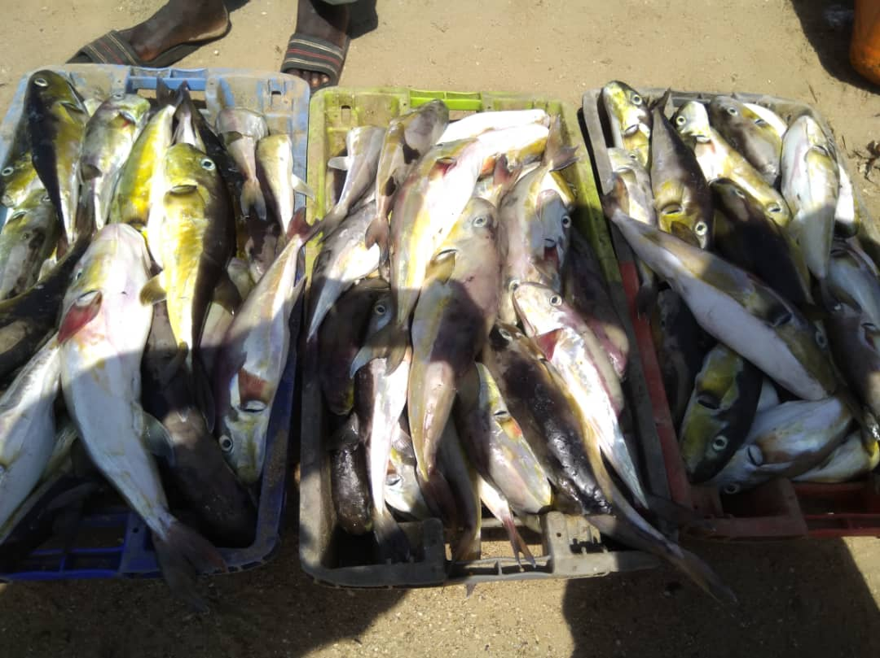:$2.41/k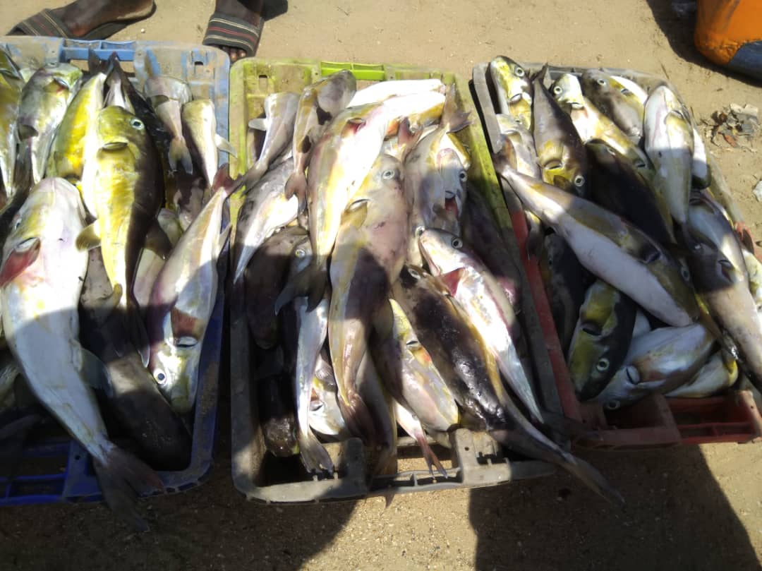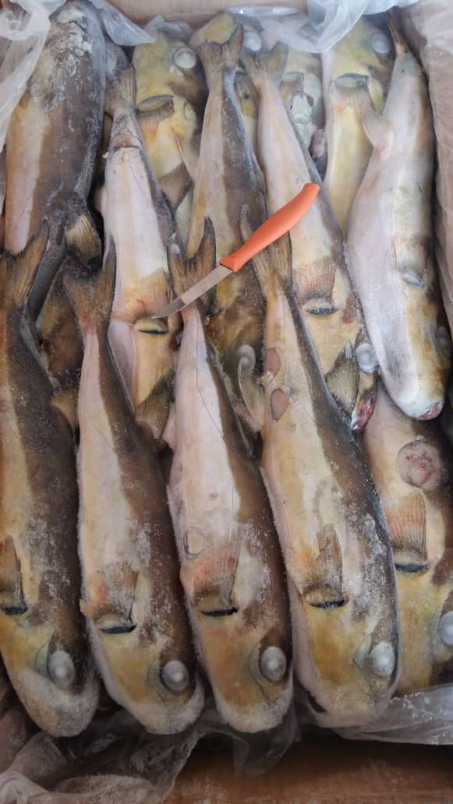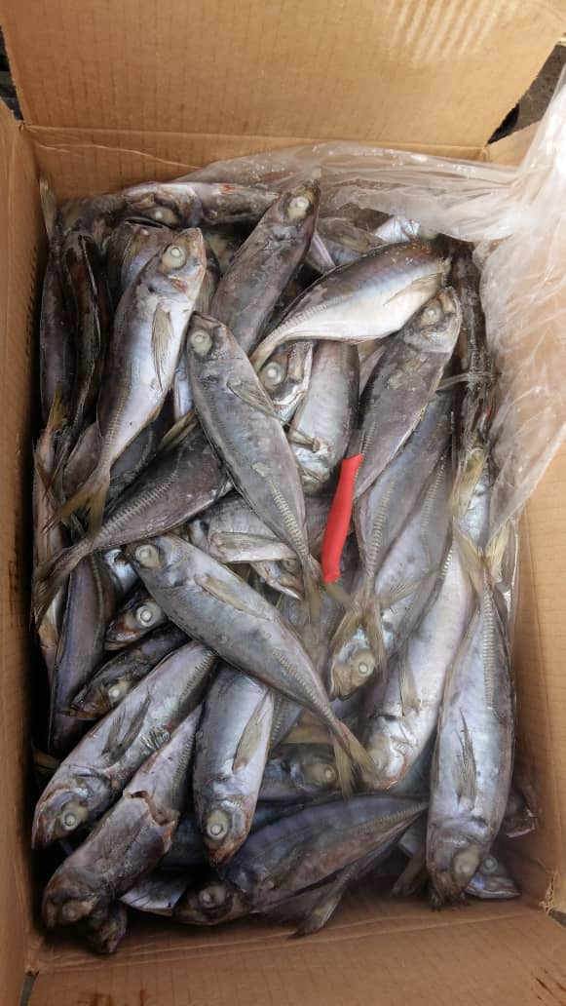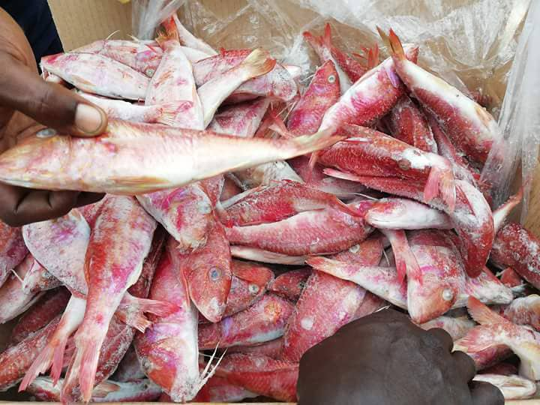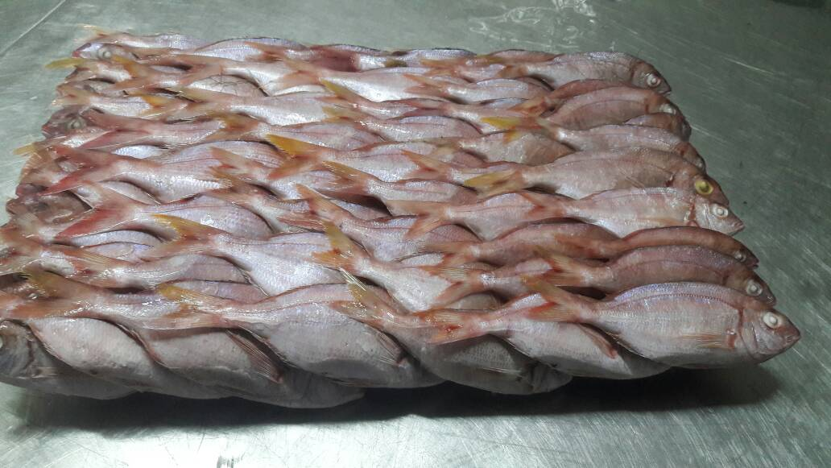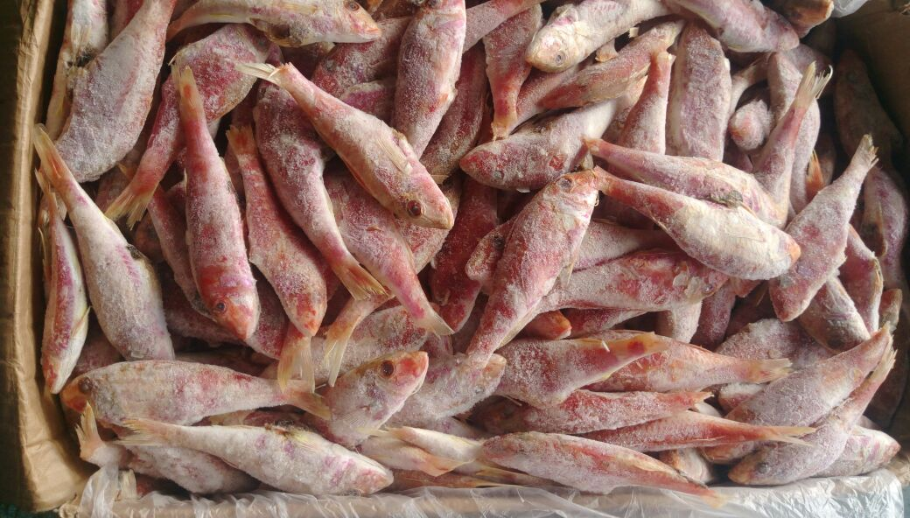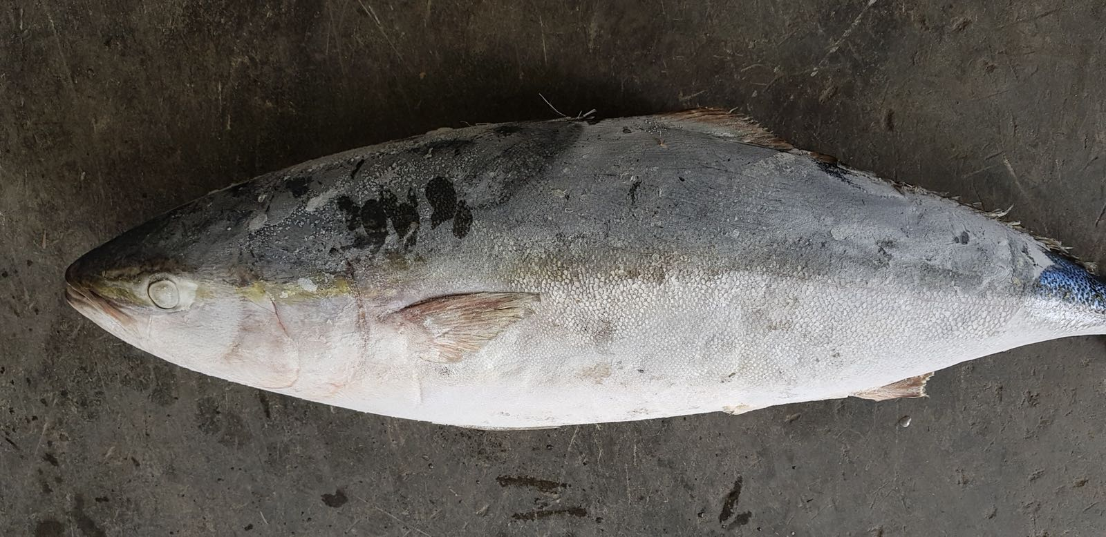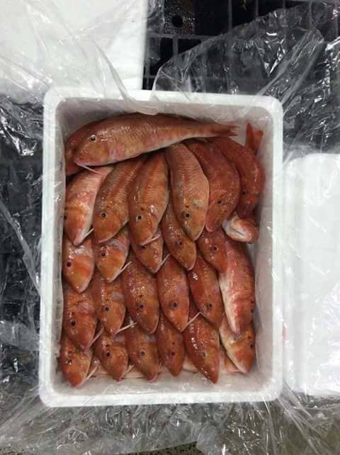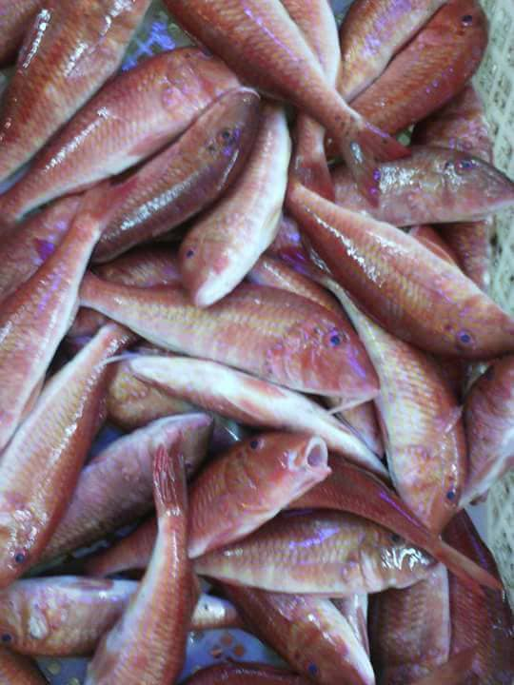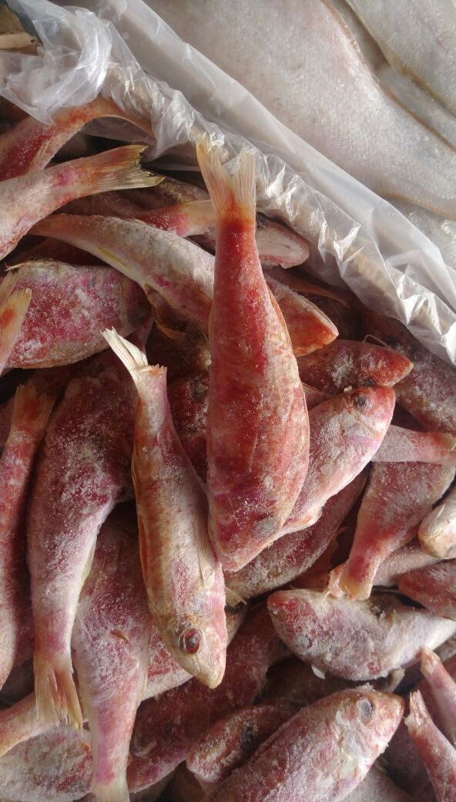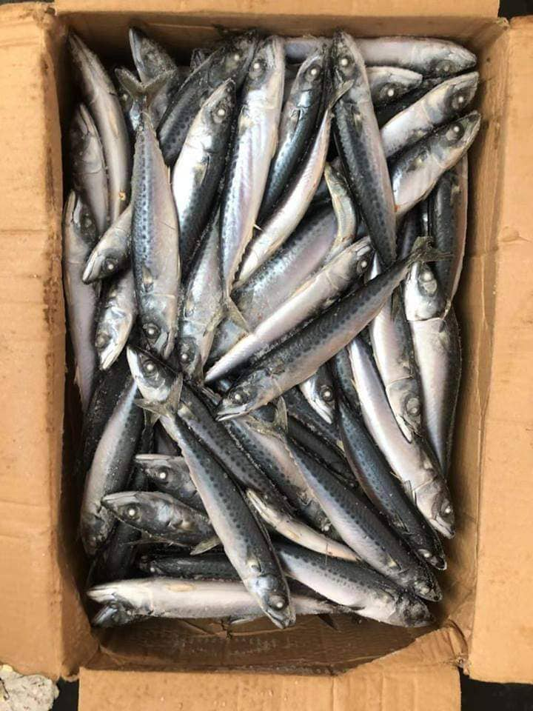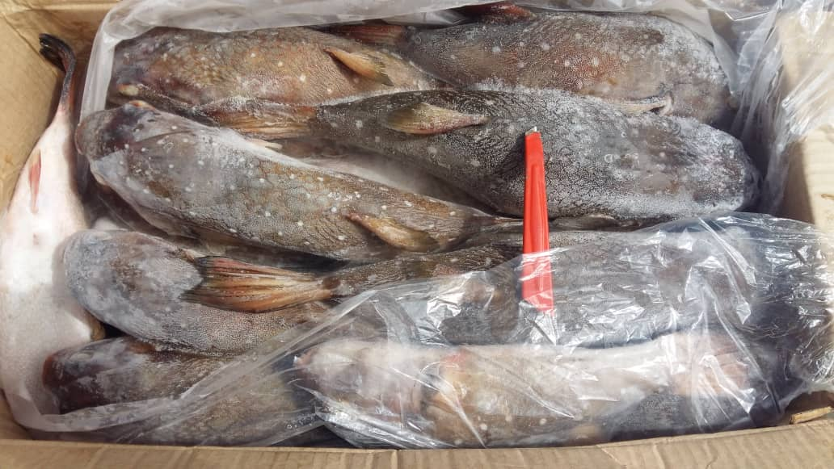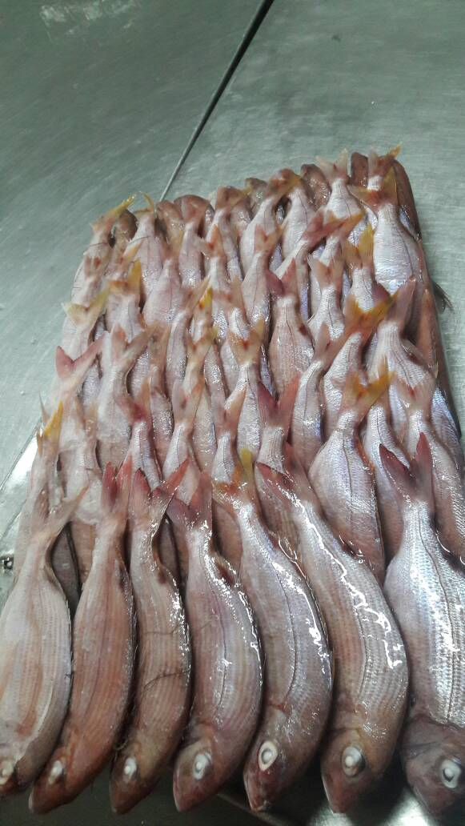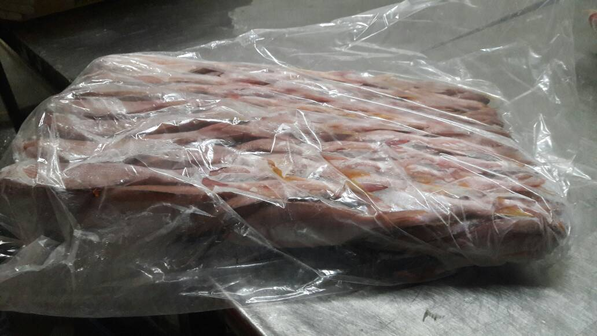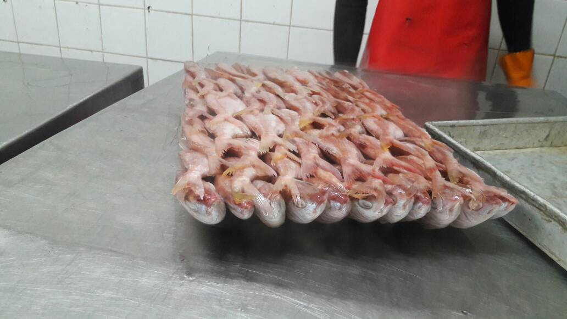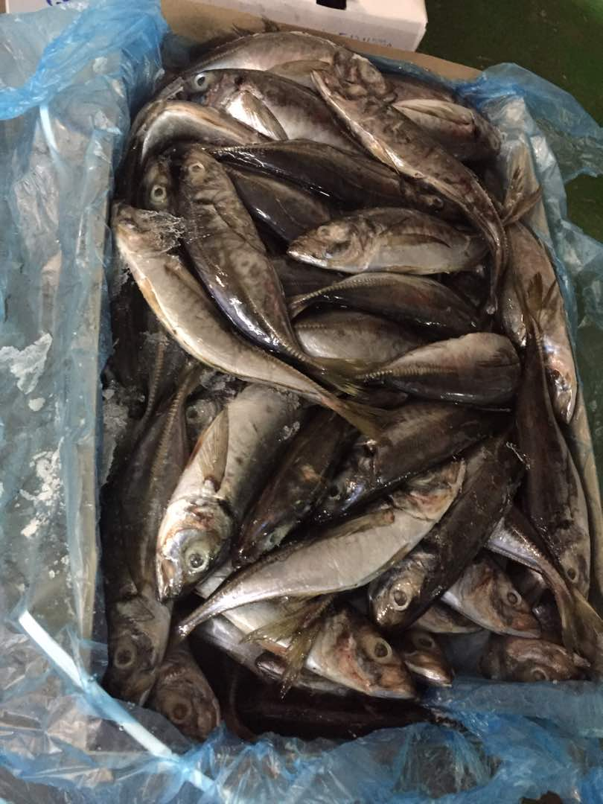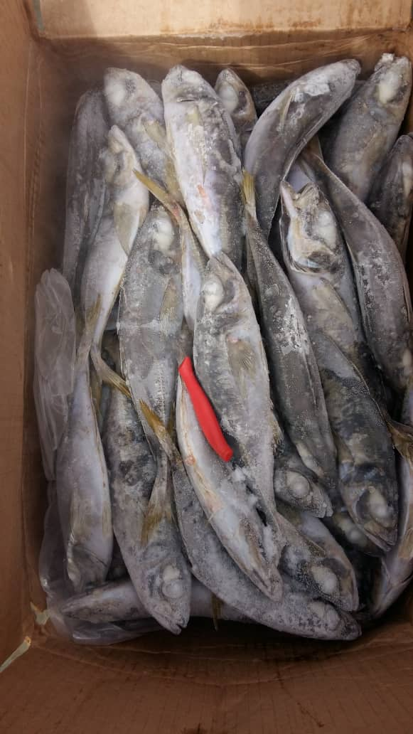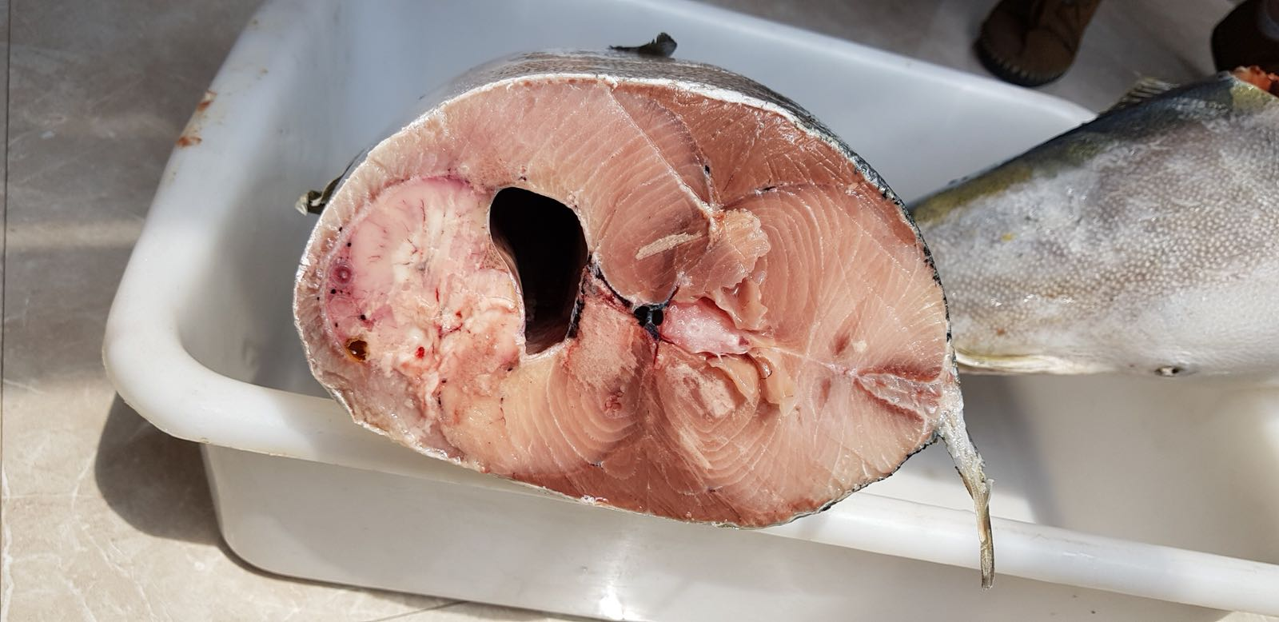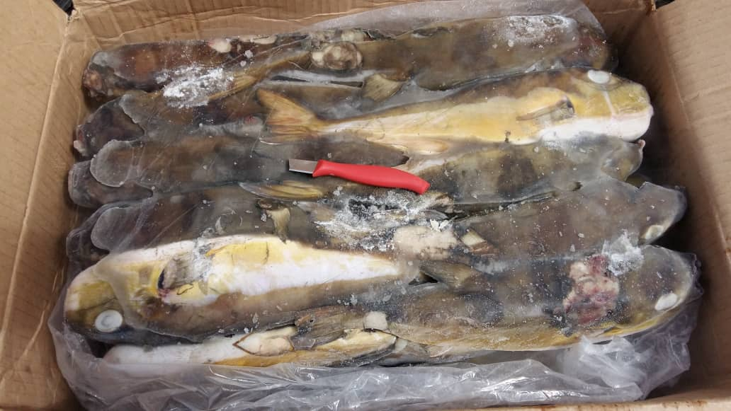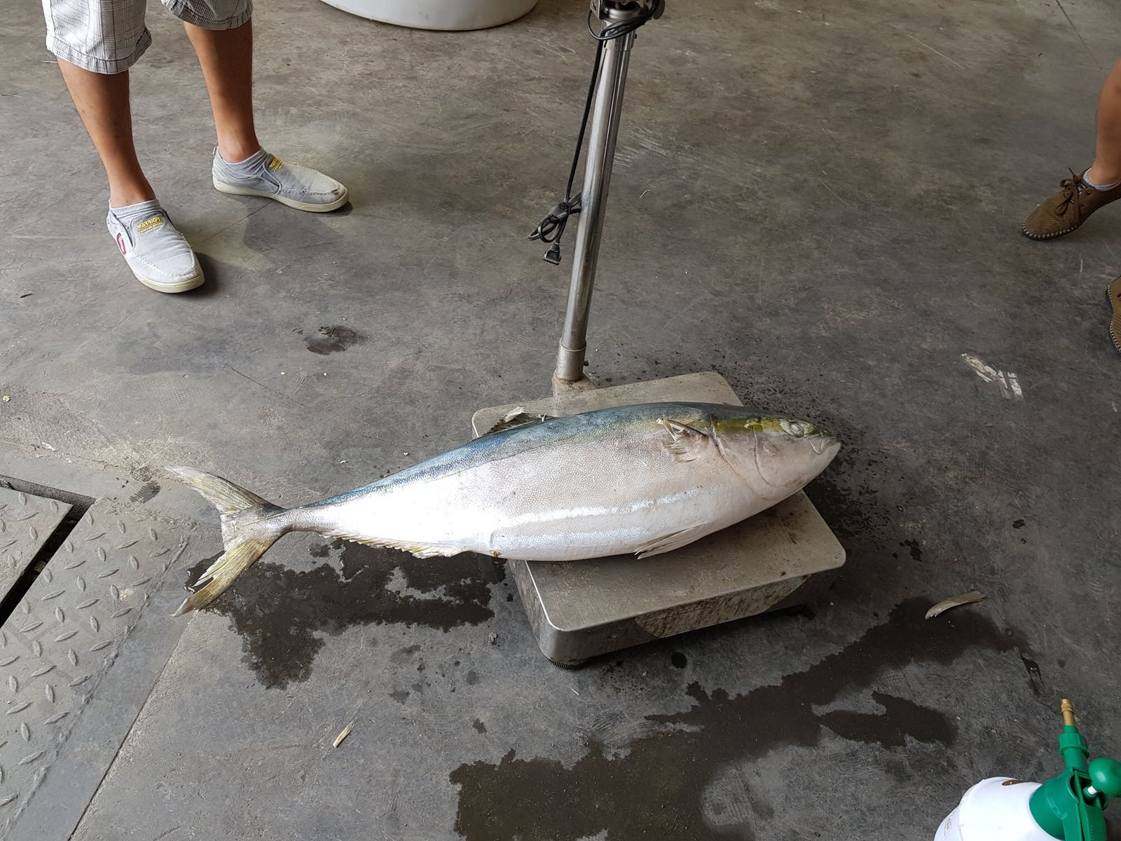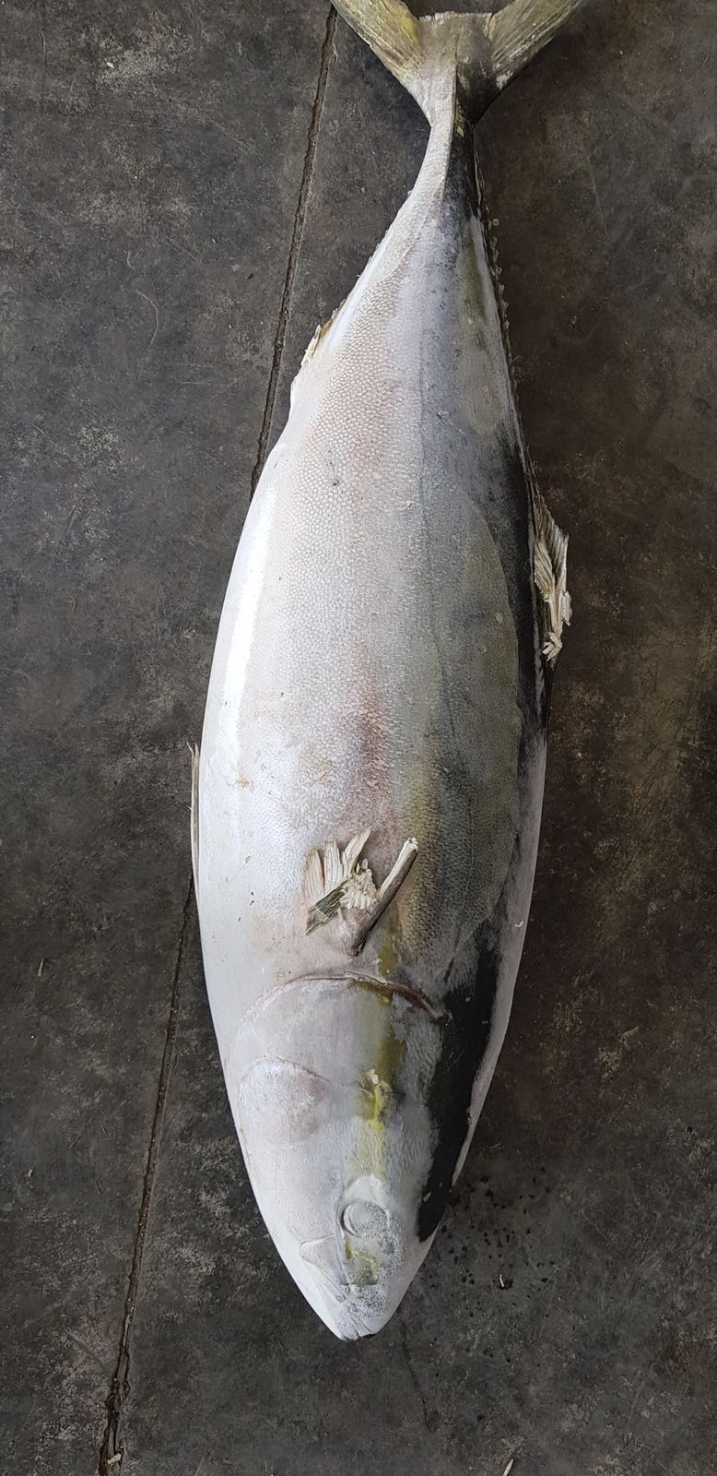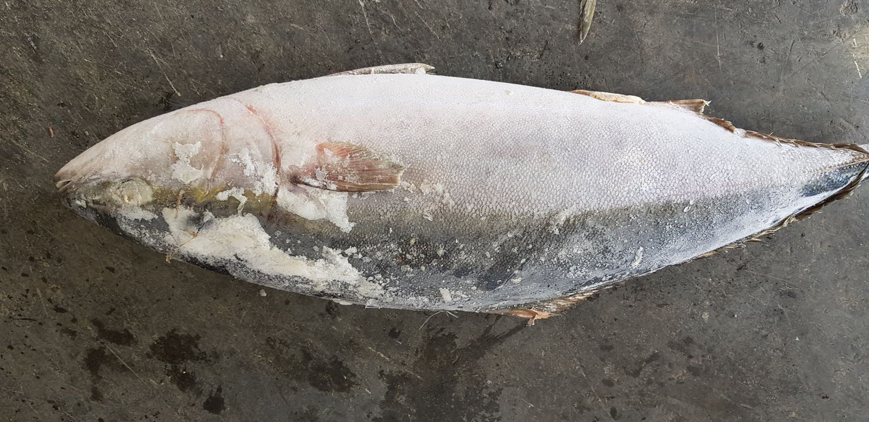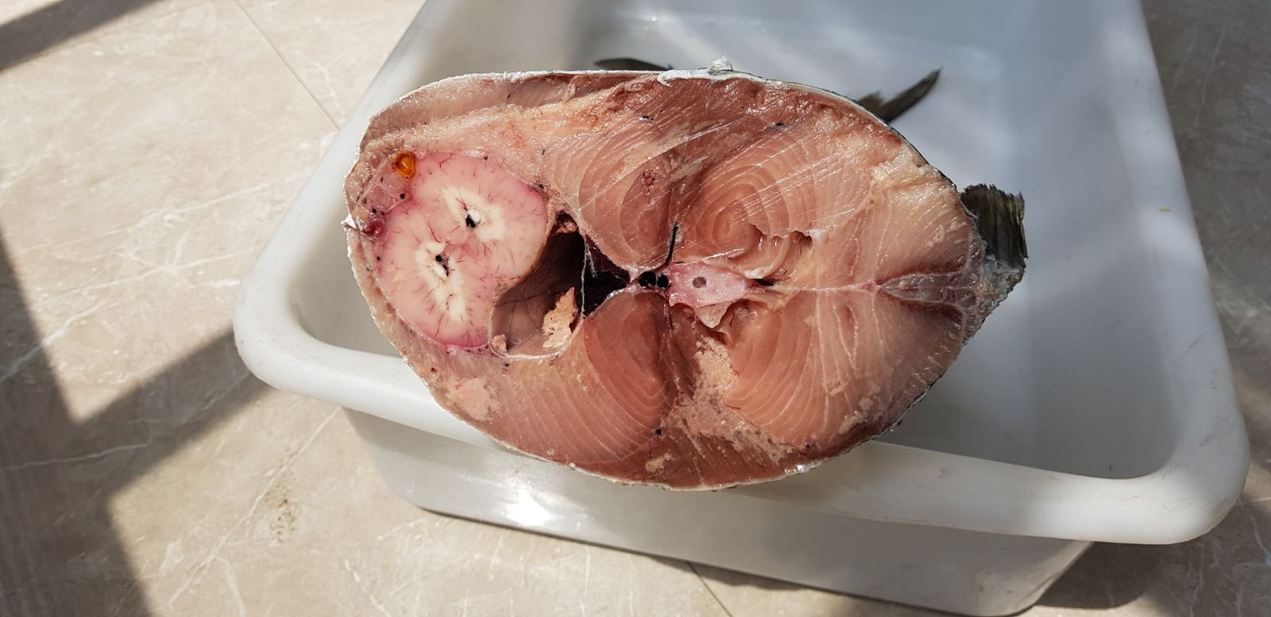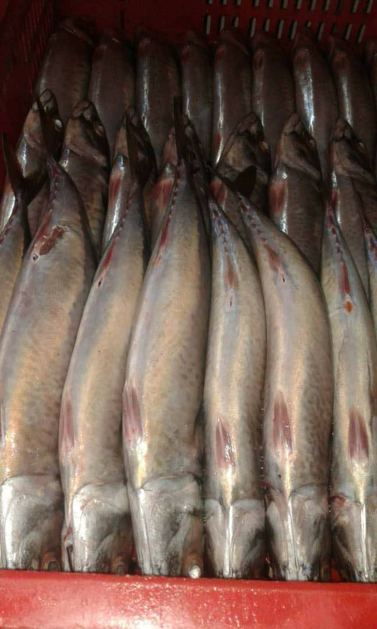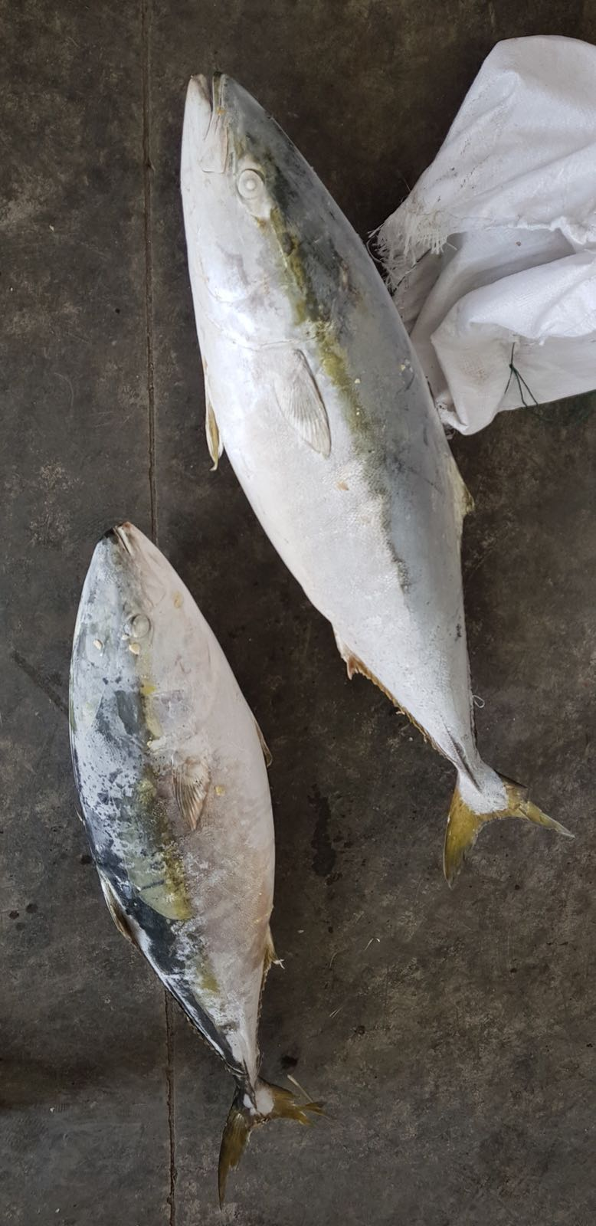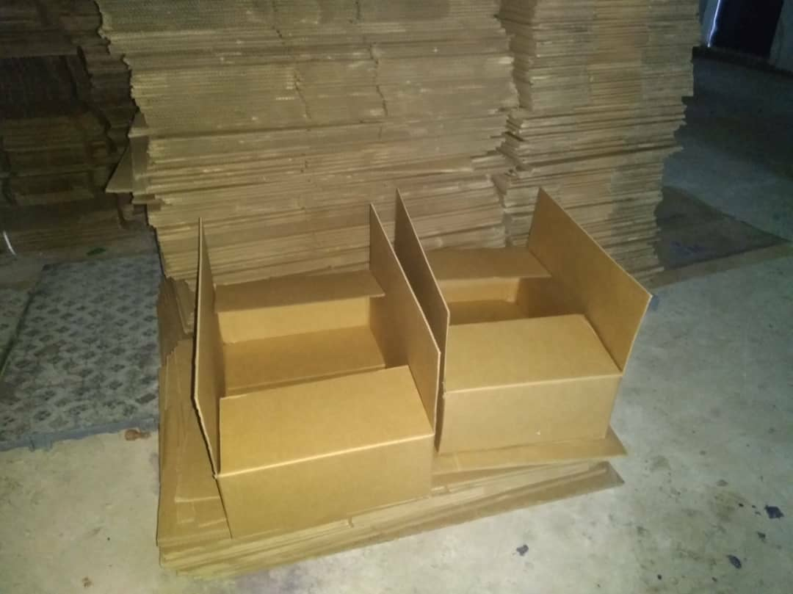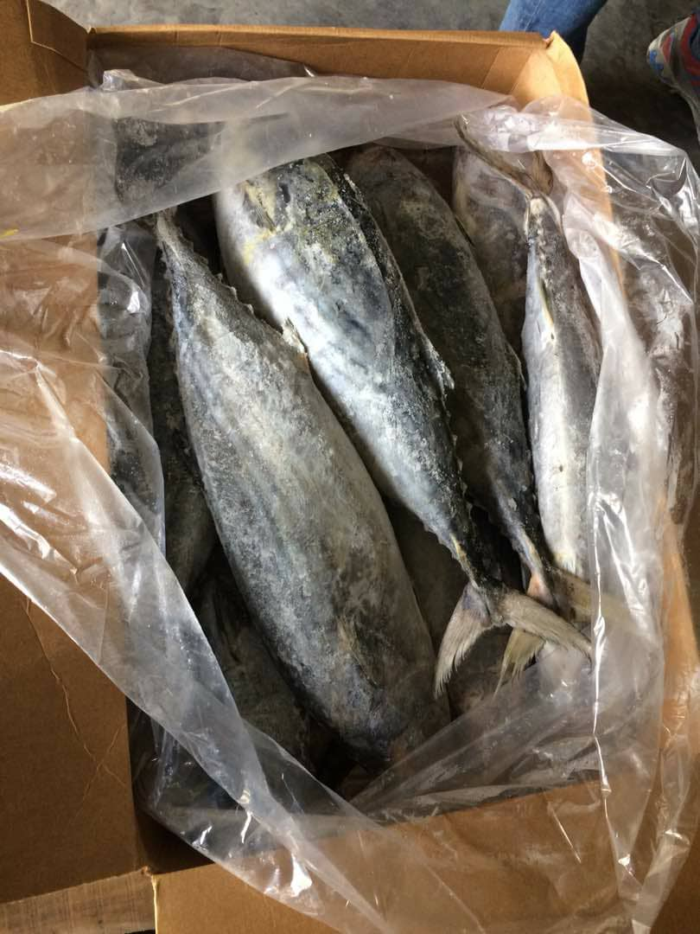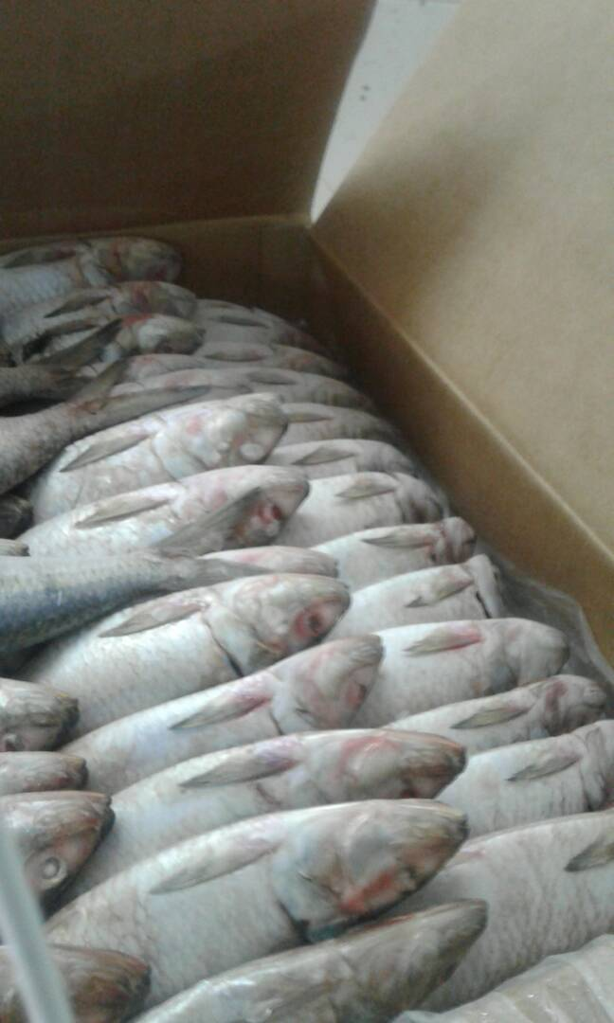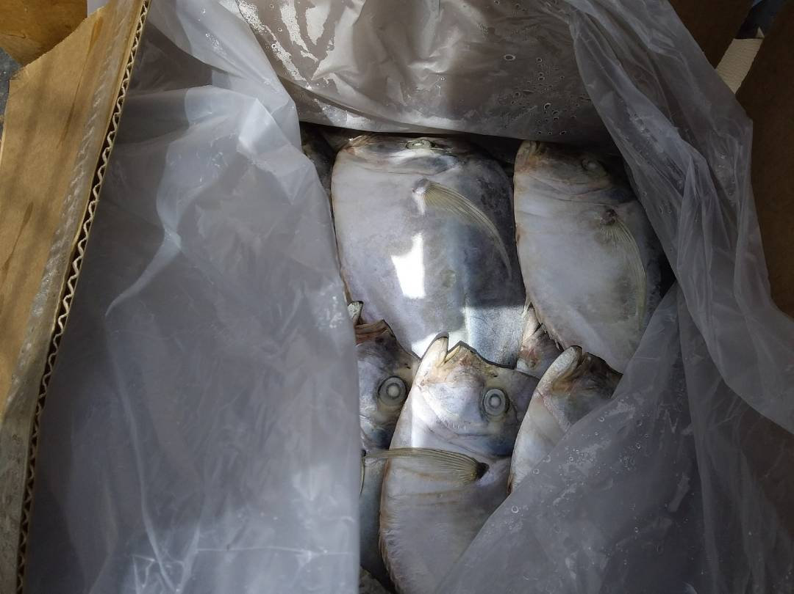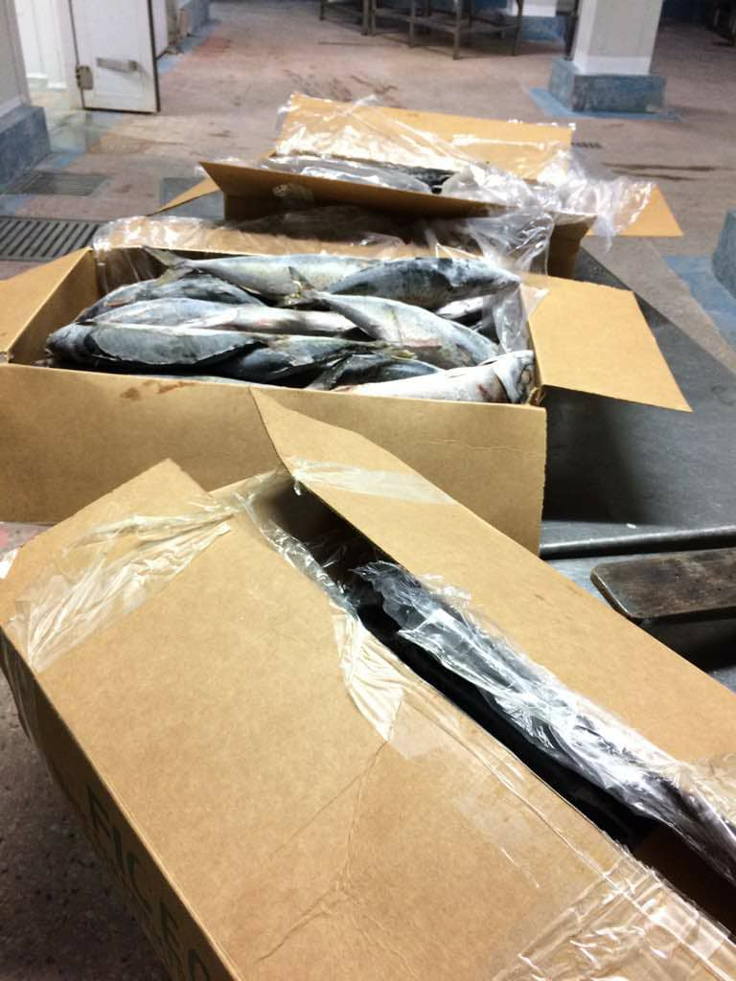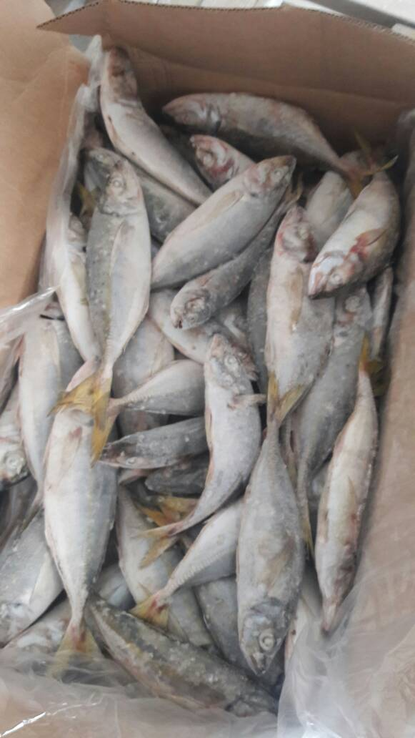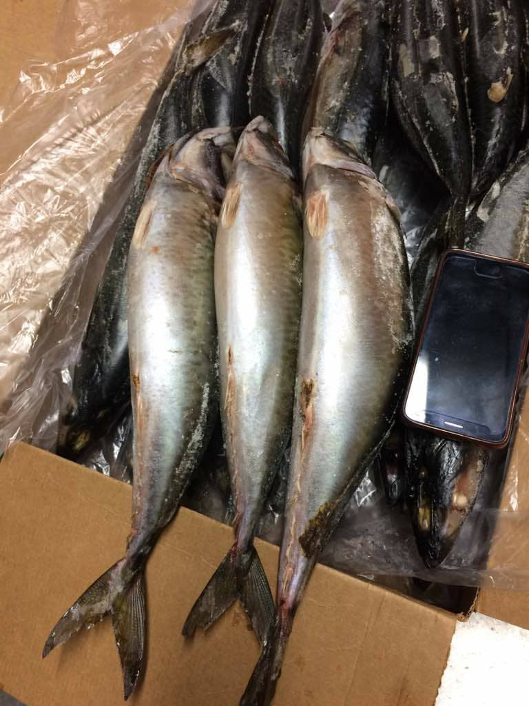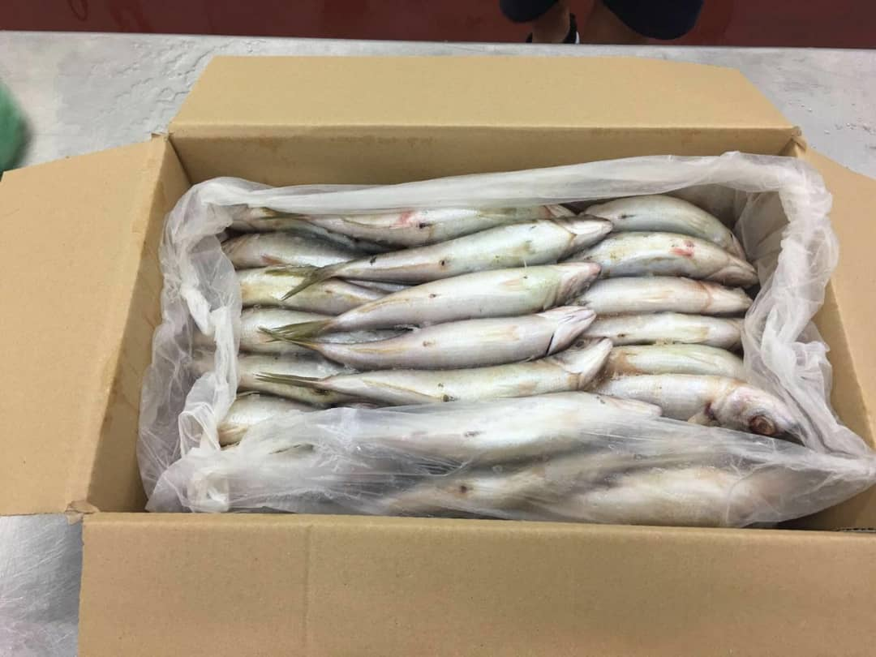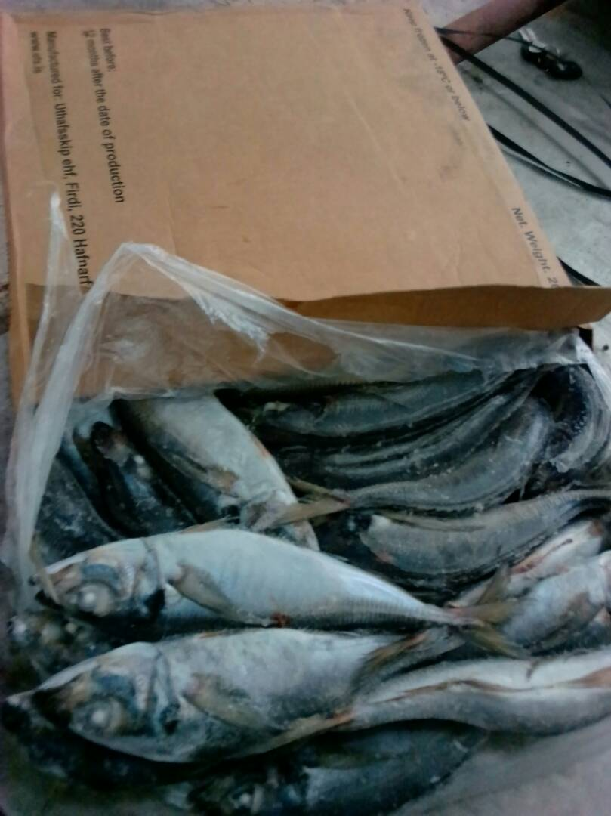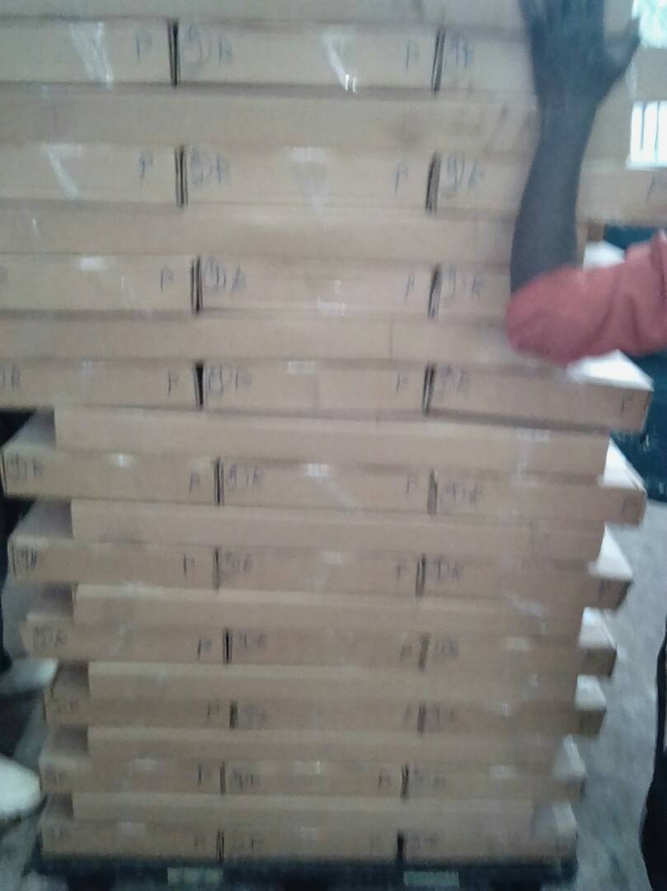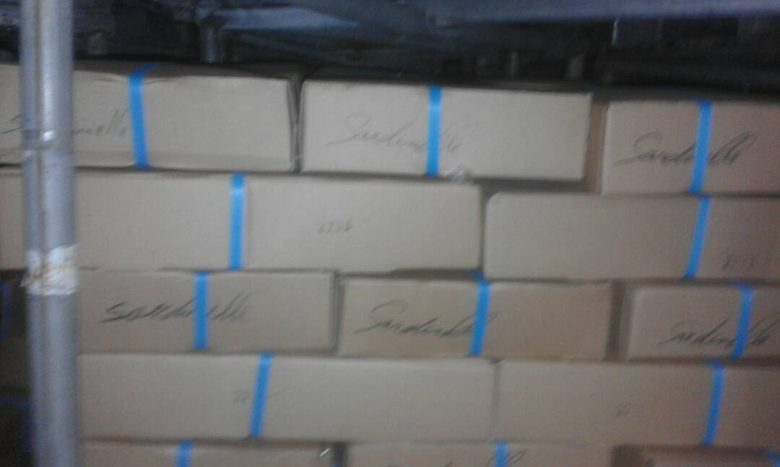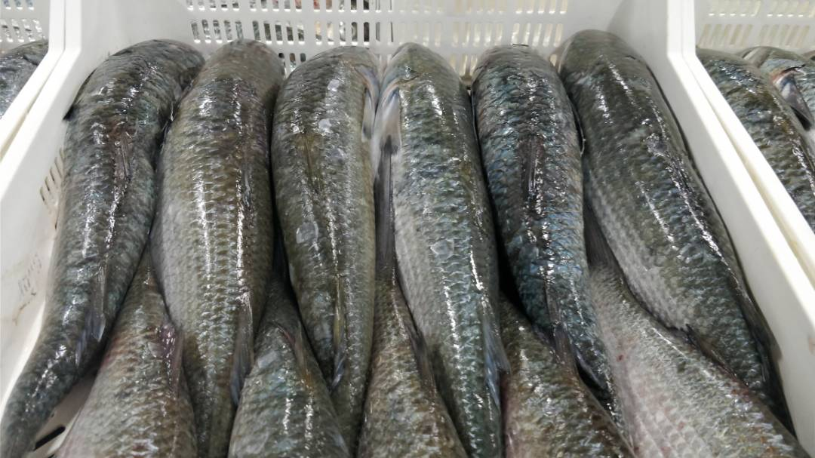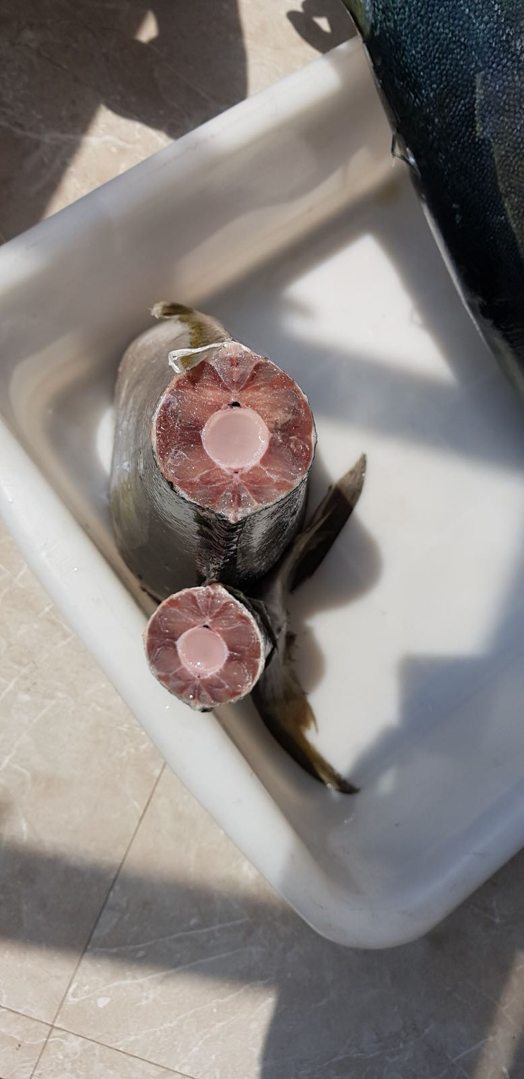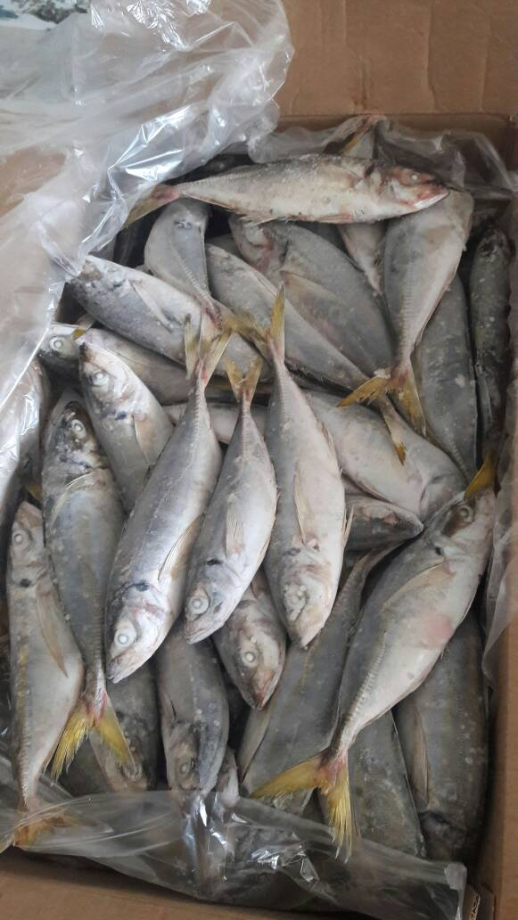g

