WOODPECKER CNC
INSTRUCTIONS

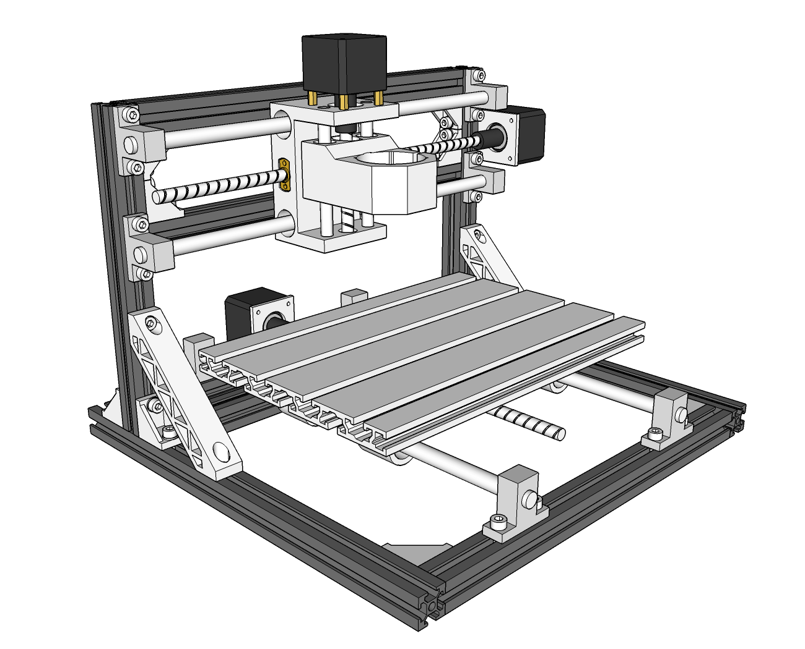
V2.5
- Size of some parts：
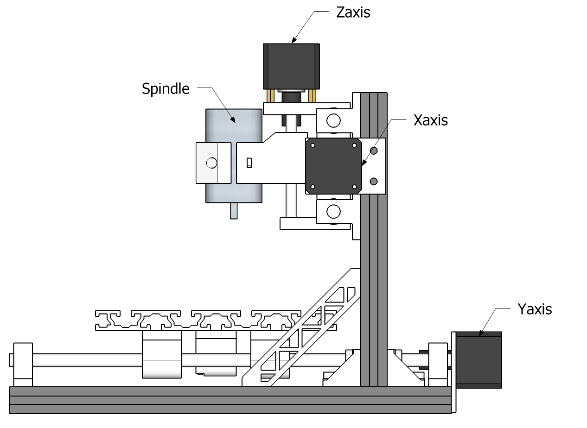
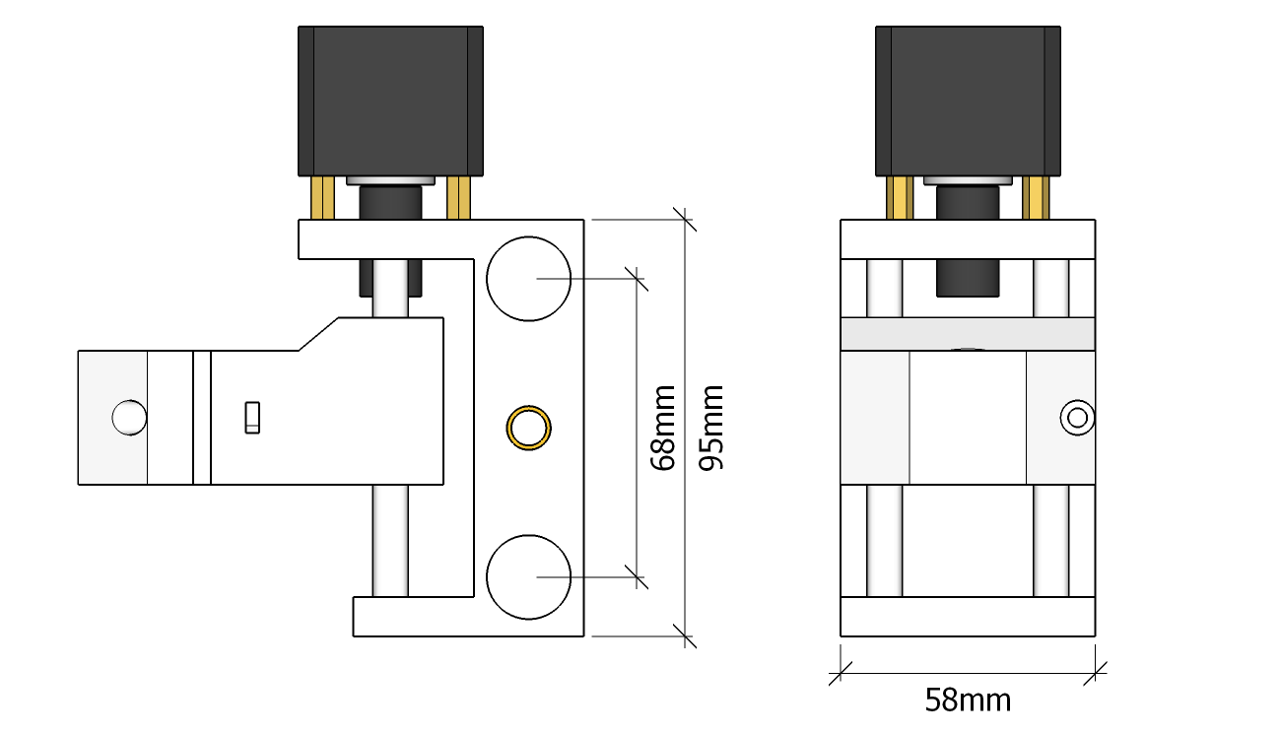
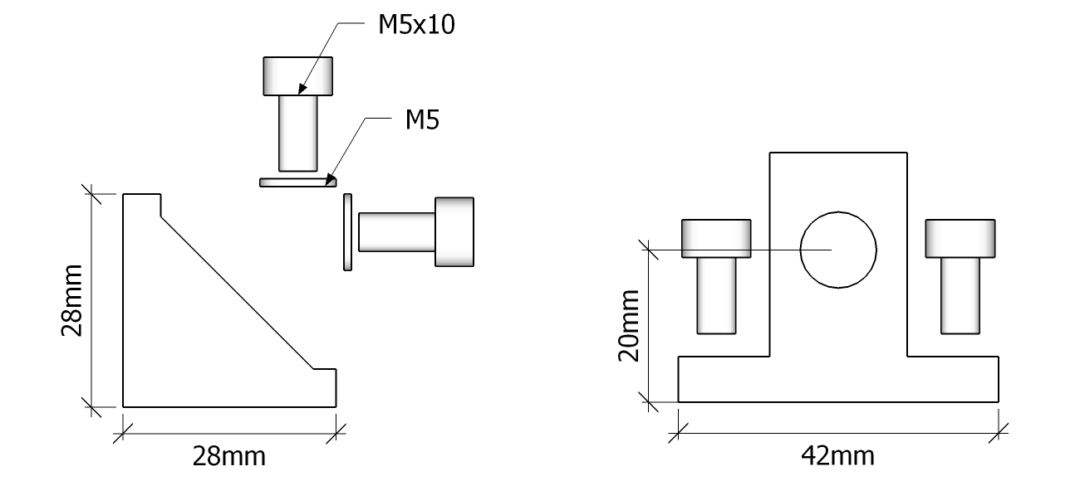
1.Frame 1
  - Base：330mm×2、300mm×3、Angle Support×6、
  - M5*10×12、Spacer×12
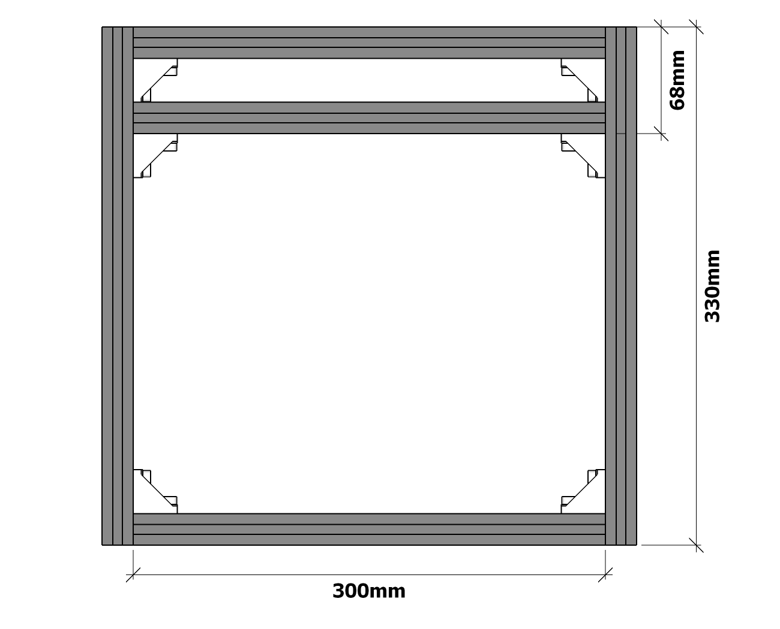
- Frame 2：220mm×2、300mm×2、Angle Support×4、
M5*10×8、Spacer×8
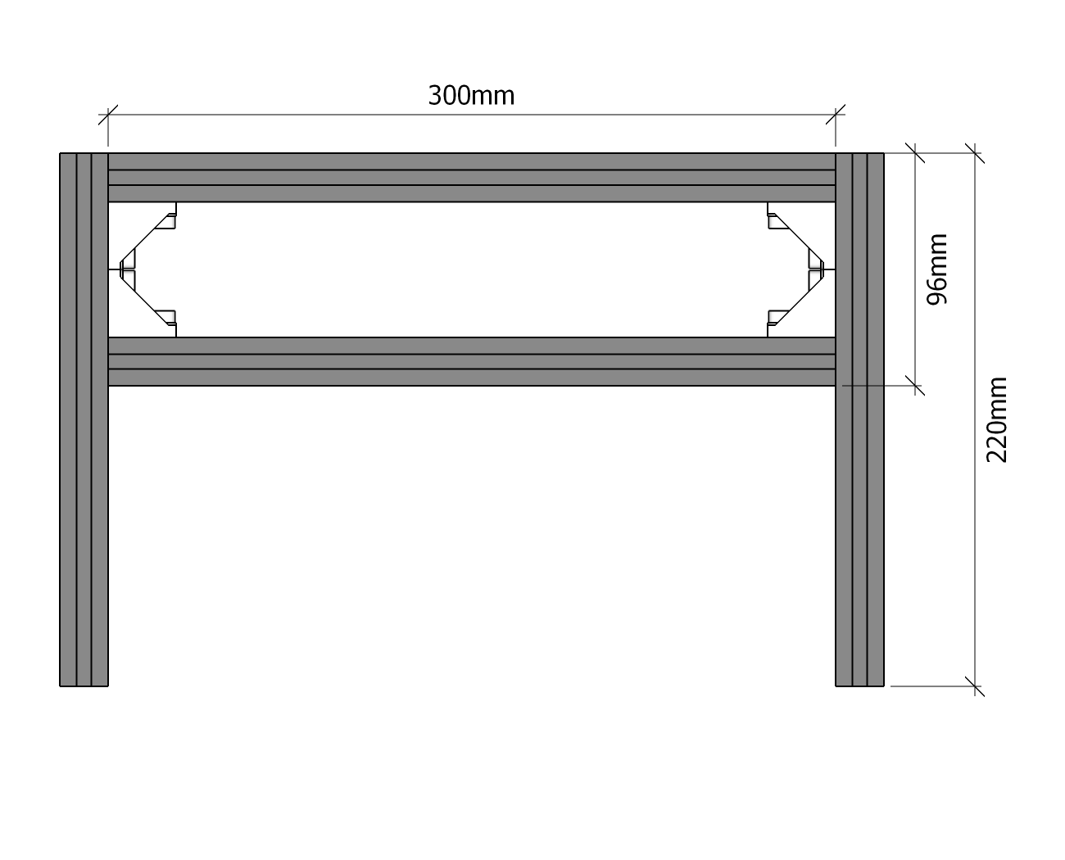
- Frame 3：Angle Support×6、M5*10×16、Spacer×12、
Connecting piece×2
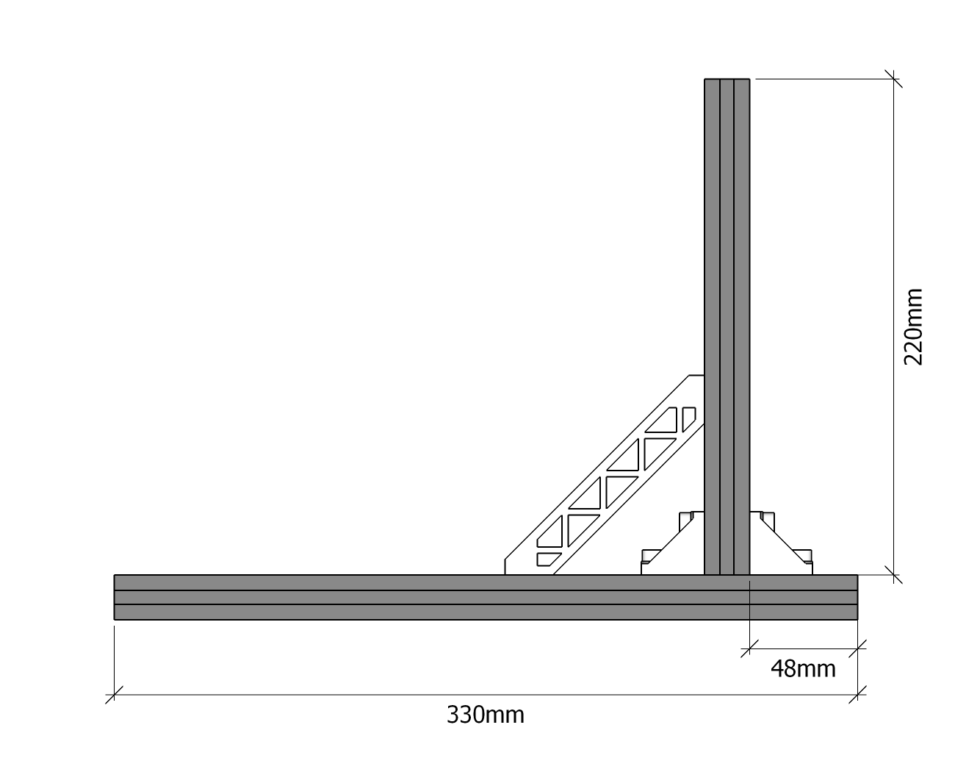
- Size of Polished Rod Supporting Base 1：
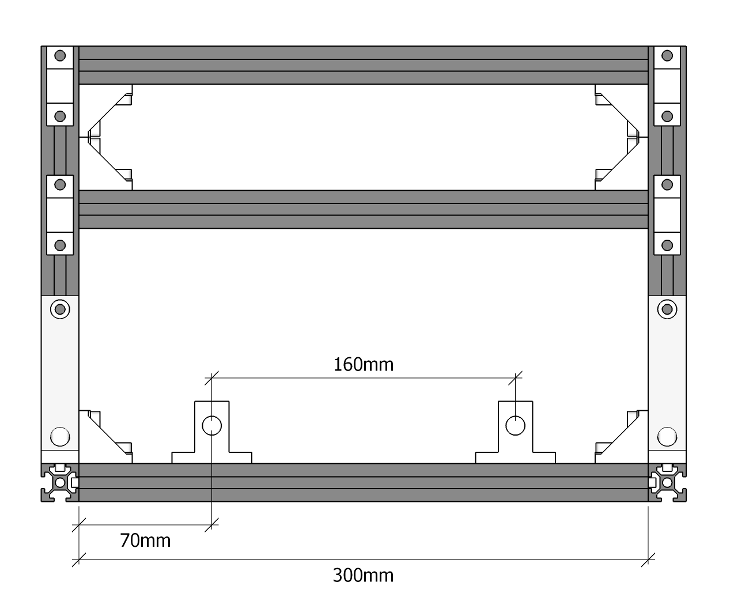
- Size of Polished Rod Supporting Base 2：
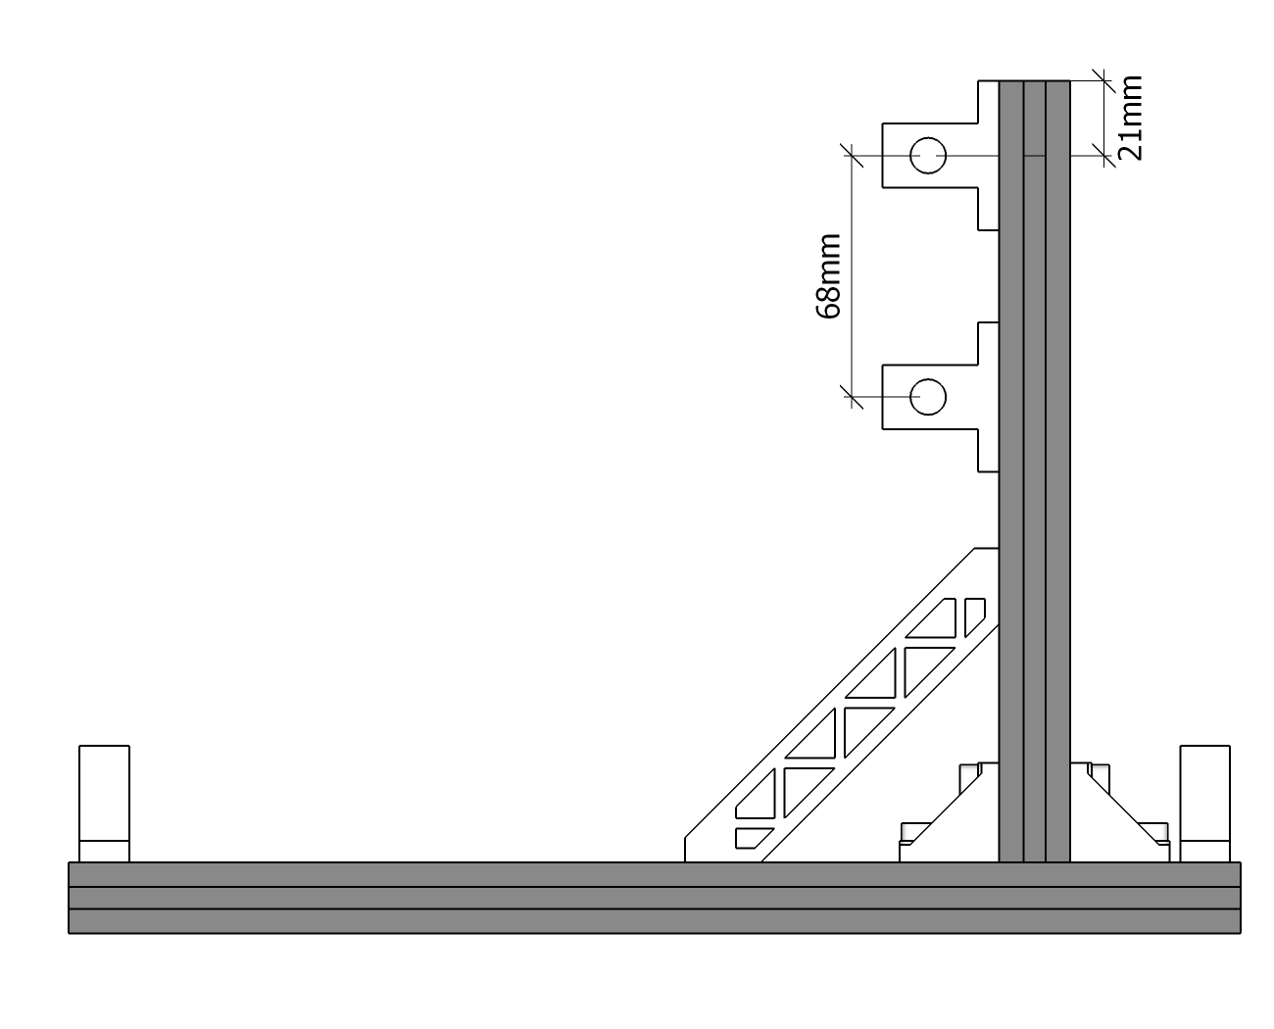
- Y-axis Assembly：M6*12×10、Sliding Block×5、Worktable×1
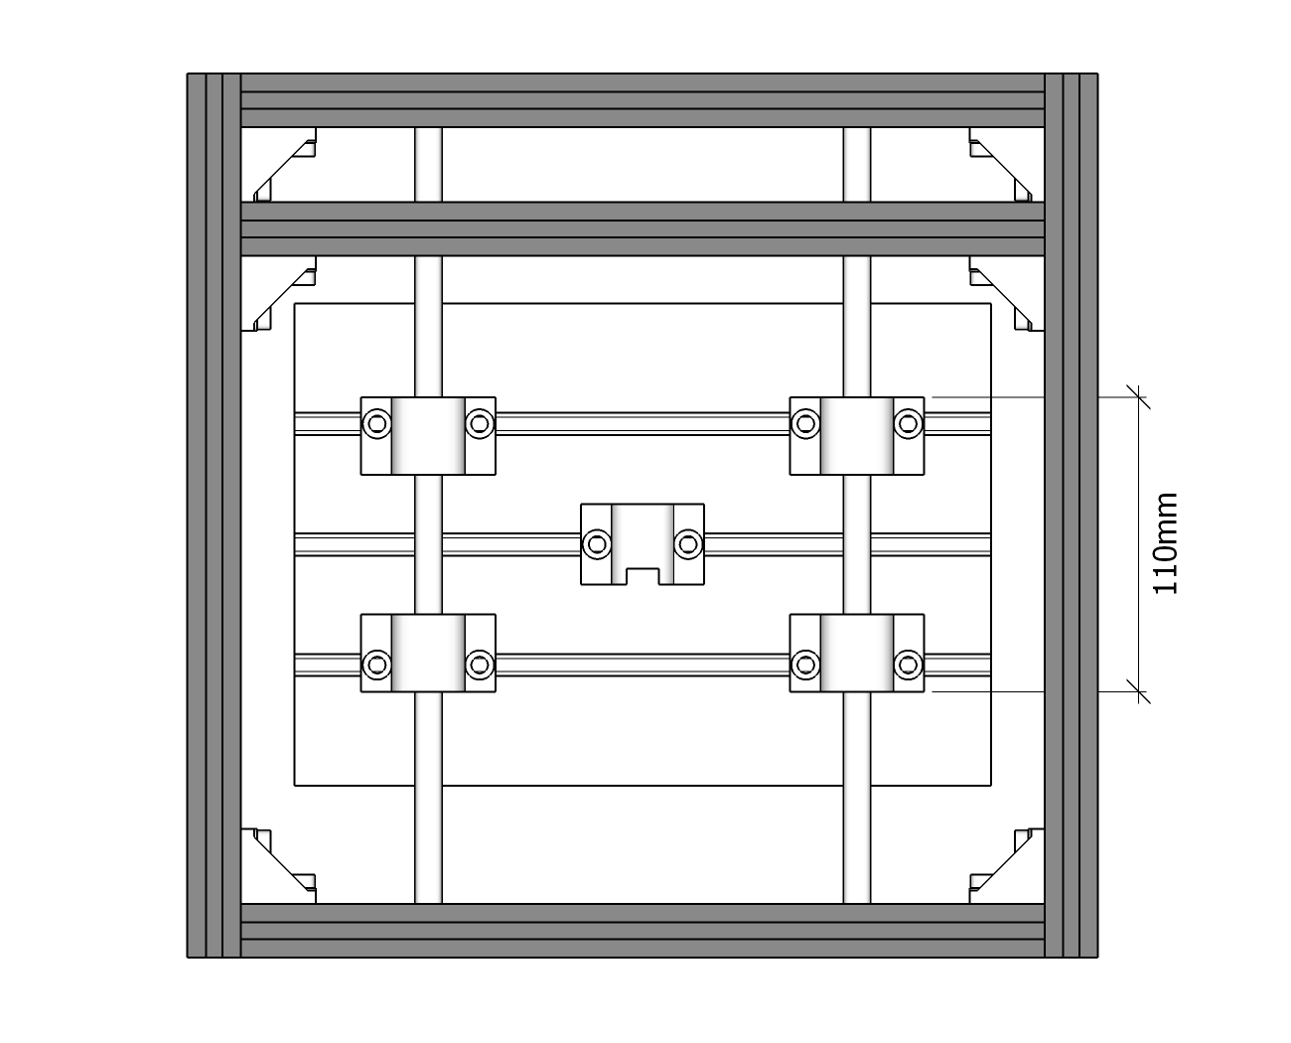
- Stepper motor assembly
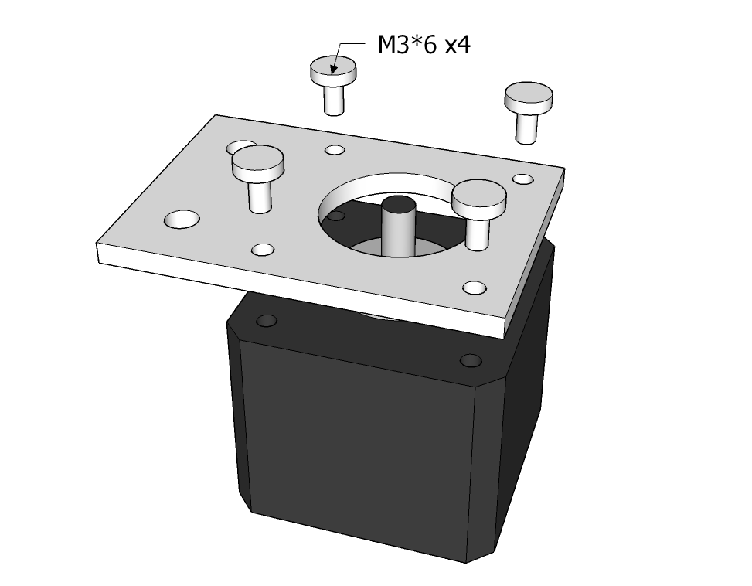
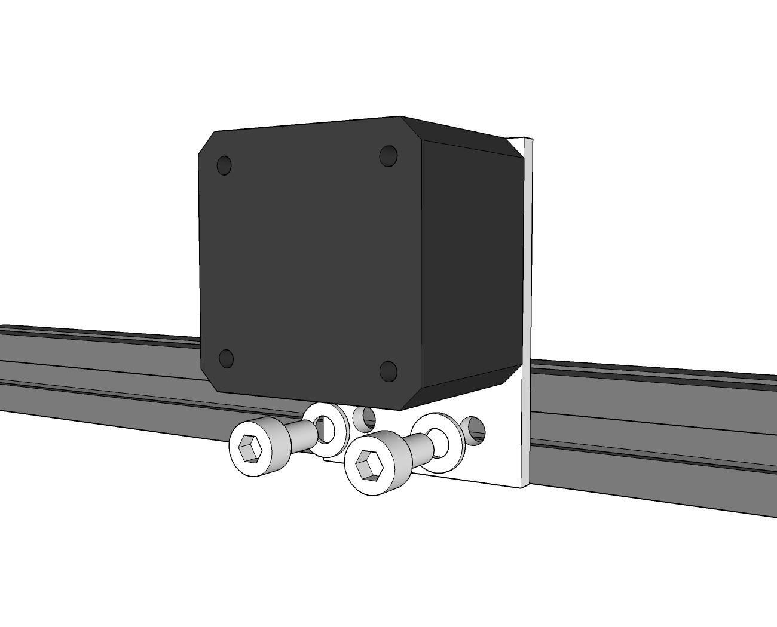
- XZ Axis Assembly
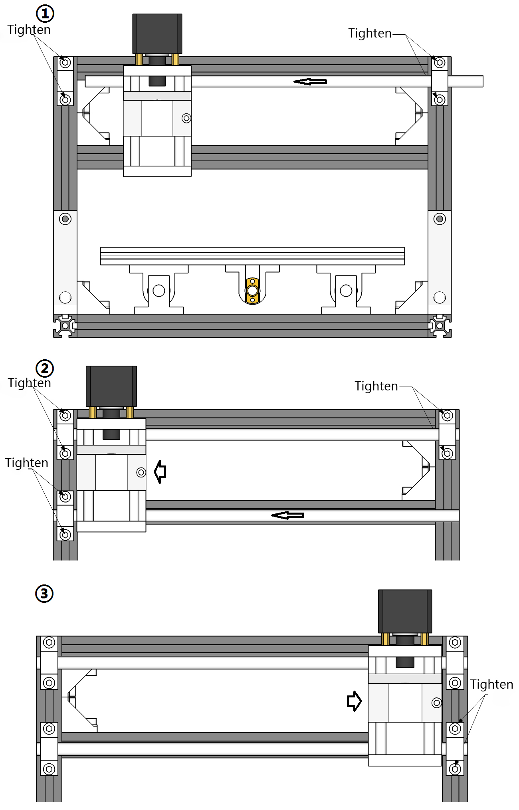
Lead screws installation
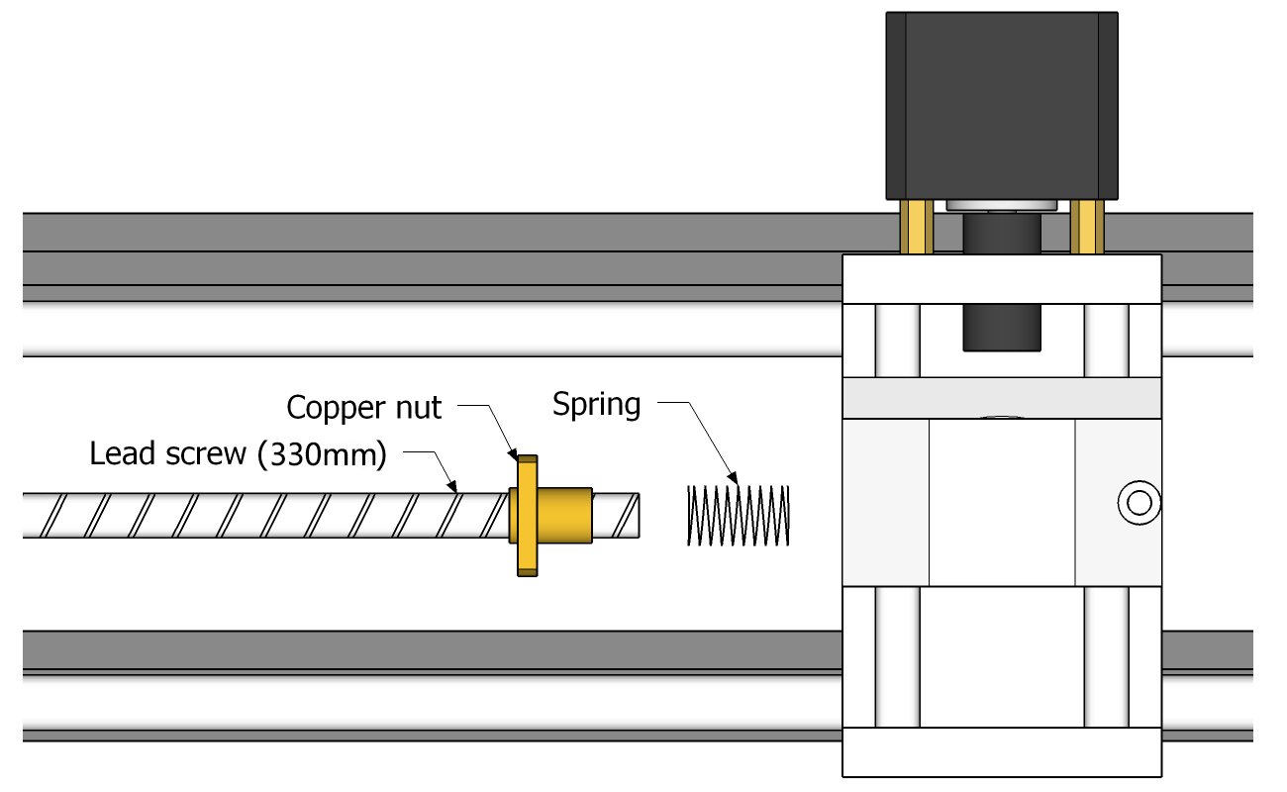
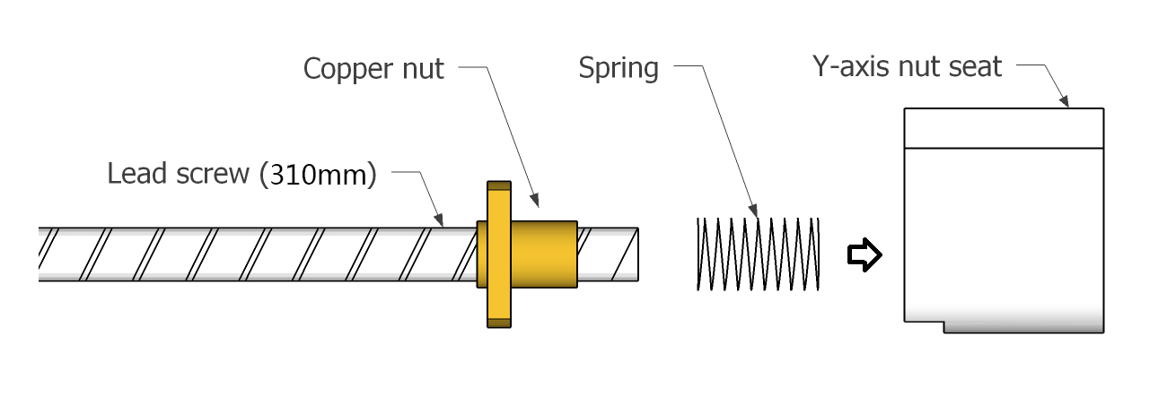
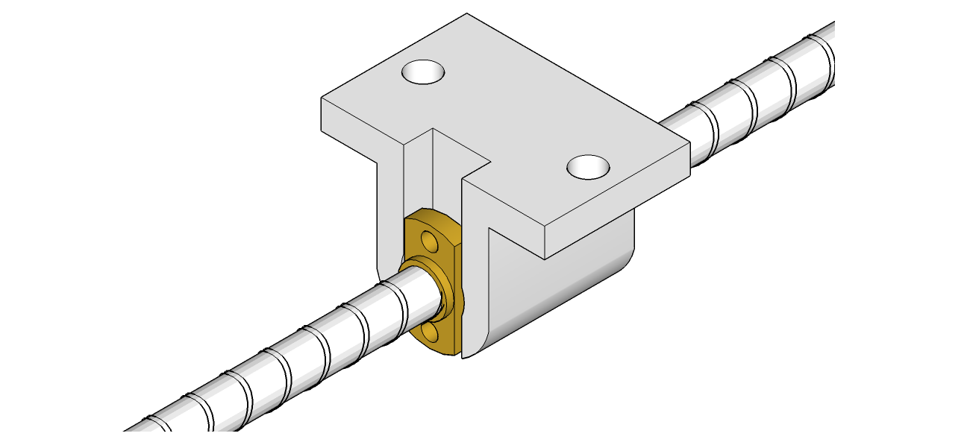
- Couplings Assembly：
Tighten two screws from one side only
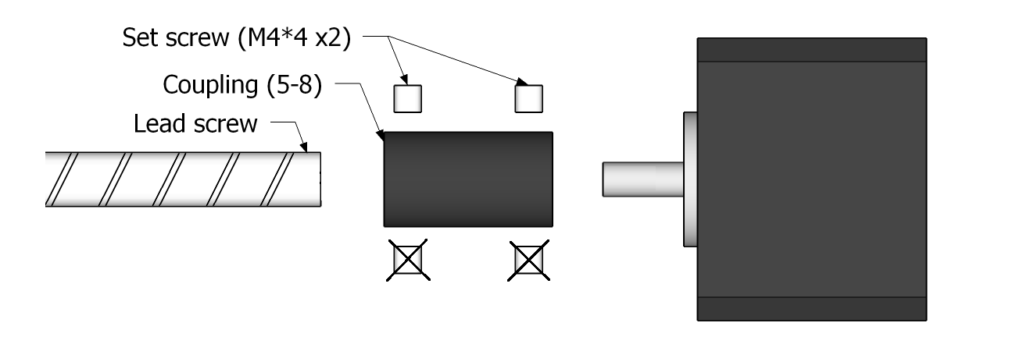
- Bearing Assembly
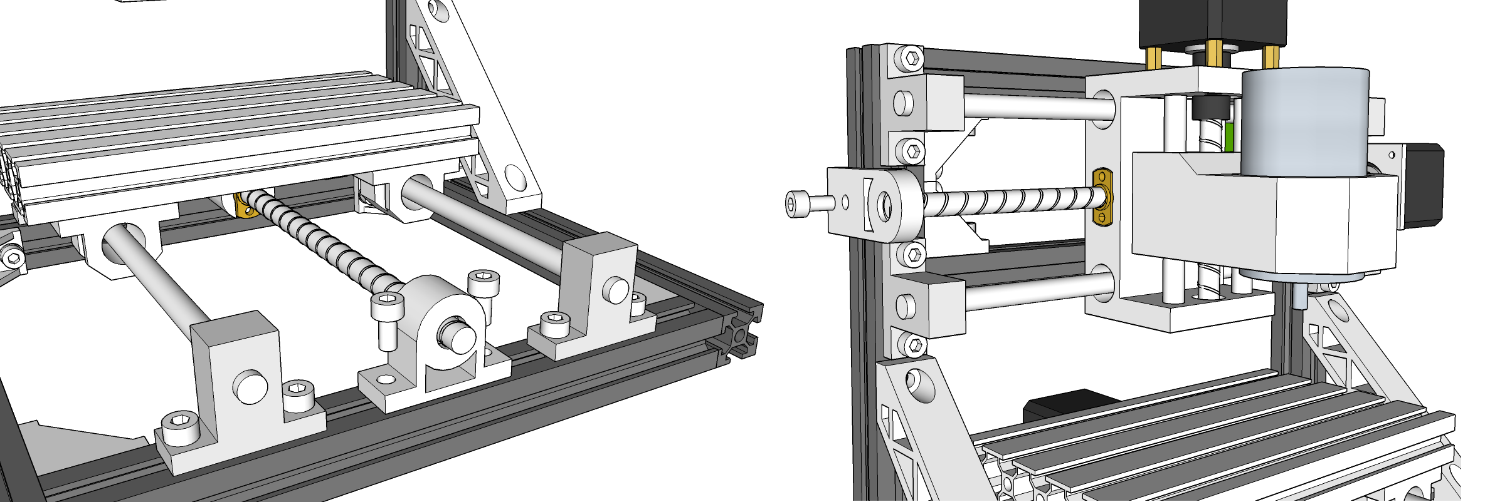
2. Control Board Assembly
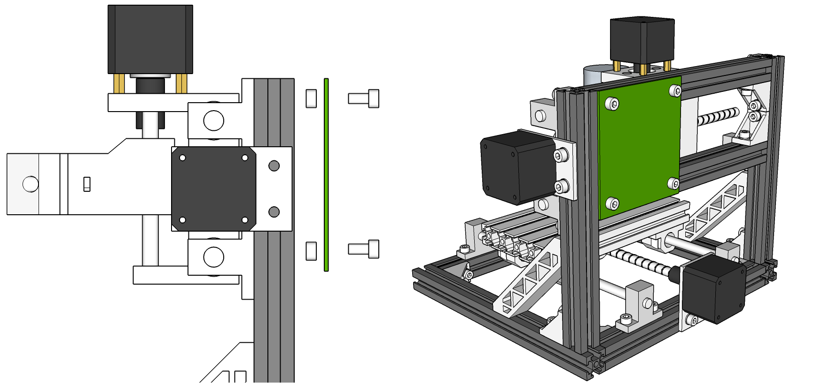
Wiring Diagram

