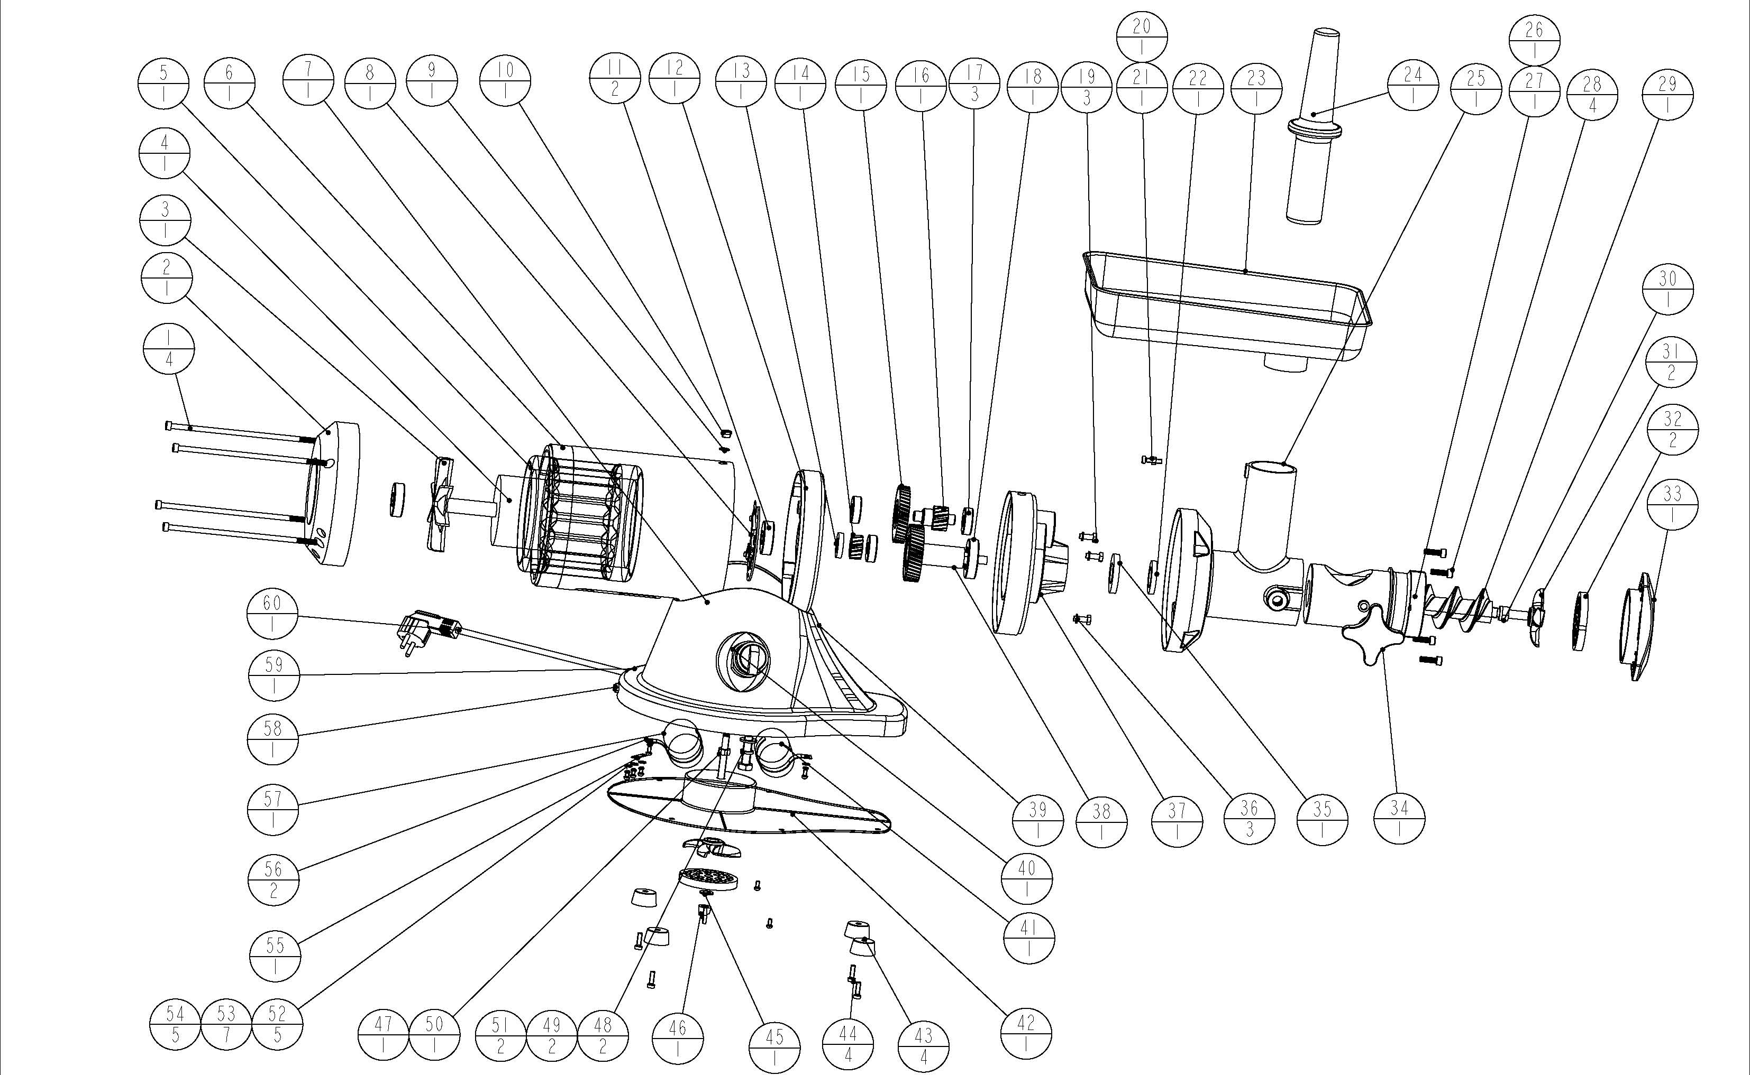

PART NO. | DEXCRIPTION | QUANTITY
1-22，25，35-38 | MOTOR | 1
23 | FOOD TRAY | 1
24 | PESTLE | 1
27 | MINCER BLOCK | 1
28 | 内六角螺钉 | 4
29 | SCREW FEEDER | 1
30 | BLADE SAHFT | 1
31 | BLADE | 2
32 | DISK | 2
33 | SCREW COVER | 1
34 | LOCKING HANDLE | 1
39 | WORKTABLE | 1
40 | SWITCH | 1
41 | CAPACITOR | 1
42 | BOTTOM BOARD | 1
43 | RUBBER FEET | 4
44 | SCREW | 4
45 | FLAT WASHER | 1
46 | LOCKING SCREW | 1
47 | SHAFT | 1
48 | HEXAGON BOLT | 2
49 | FLAT WASHER | 2
50 | SCREW | 1
51 | SPRING WASHER | 2
56 | CAPACITOR HOLDER | 2
57 | CAPACITOR | 1
58 | OVERLOAD PROTECTOR | 1
60 | POWER PLUG | 1

