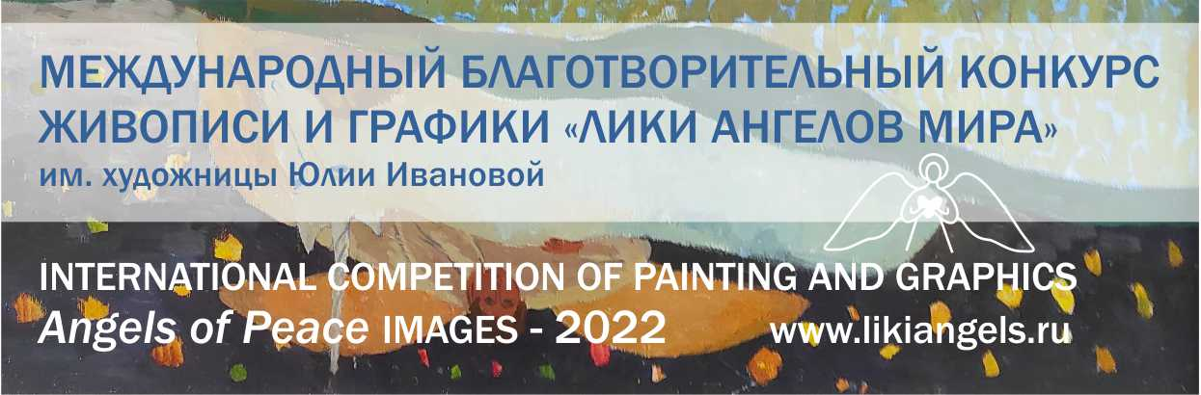
International Charitable Contest of Painting and Graphics "Images of the Angels of Peace" named after an artist Yulia Ivanova
01.02 – 15.04.2022
Nowadays modern art very successfully solves the problem of conveying the “pains” of society, the problems of our everyday life. But conveying creative, spiritual themes in the actual artistic language, giving the viewer inspiration, aesthetic pleasure, the brightest emotions is a more difficult task. To create such images and be able to professionally embody them on canvas or paper is very valuable!
The annual competition "Images of the Angels of Peace" will tell about talented artists, about their works on the theme of Angels, giving the audience Light and Love.
The project is not tied to any particular religion, it is open to everyone. All works admitted to participation will be published on the project website and in the electronic catalog of the contest (it is possible to issue a printed version of the catalog). The best works will be made in the form of reproductions, shown at several offline exhibitions and then transferred to oncological centers in Russia. All participants receive Diplomas of the international contest. Winners will also receive special prizes from partners.
Competition deadlines
- Deadline for registration of works: February 1 to April 15, 2022.
- Announcement of winners: May 31, 2022.
- Offline exhibitions: June-November 2022.
- Distribution of posters to hospitals: December 2022.

Competitive areas
- Painting
- Graphics (unique, printed and digital)

Competitive nominations
- Angels and children
- Religious stories
- Angels are always near
- Images of Angels
- Аngels and chapels

Competitors
Artists over 18 years of age from any country in the world.
- Professionals (artists with specialized education)
- Amateurs (courses of painting and graphics, self-education)
- Students of specialized educational institutions

Participation format
Online participation (correspondence), paid.
All funds are used to organize the competition, filling the site with works, creating a catalog, holding offline exhibitions, printing posters of the best works for their subsequent transfer to Russian oncology centers.

The terms of participation
- The number of works from one participant - no more than five.
- Applications are sent to the organizing committee in electronic form.
- The photo of the painting must be in good quality (from 2 to 6 MB, resolution 300 dpi, jpg format). There is no need to send original paintings to the Organizing Committee.

Organizers
International Art project "Angels of Peace". Website - www.365angels.com
Curators: Natalia Yatsenko and Oleg Rovda
Mobile tel. (Viber, Whatsapp, Telegram) +7 913 532 34 16 – Oleg Rovda
likiangels@gmail.com, www.likiangels.ru, @likiangels

Why the contest named after Yulia Ivanova
In 2021, the famous Siberian artist, member of the Union of Artists of Russia, ideologist of the International Art Project "Angels of Peace" Yulia Ivanova passed away, leaving the world more than 1200 paintings. Many beautiful images of Angels were born under her brush. It will be great if more attention is paid to the topic of "angelic" painting and graphics, since this is a special miracle - the "birth of an Angel", not every artist can do this. Join us now!

