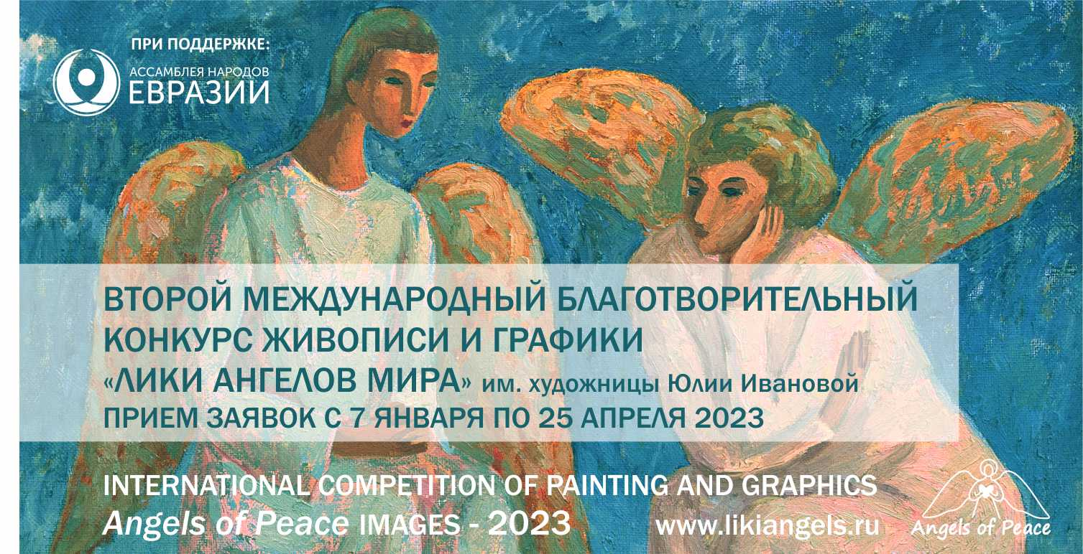
APPLICATION FORM - 2023:

-Full name
-Country, city

- Area (painting/graphics/digital graphics)
- Nomination (Angels and Children/ Religious Scenes/ Angels are Always Near/ Images of Angels/ Angels and Temples)
- Category (professional, amateur, student)
- For Professionals and Students, the name of the educational institution should be provided.

- Title of the painting
- Year of creation
- Original size of the painting
- Materials, technique

- Brief information about yourself
- Address of your website, social media accounts (if you have any)

- A short description of the picture (the message of your artwork)

- Photo of the artwork (upload a file in good quality, with a clear, full-figured image of the work, 2 to 6 MB, 300 dpi, jpg format).

By submitting an application, the Author confirms that he/she has read and fully agrees with the conditions of participation in the Competition and agrees to the processing of the submitted personal data in accordance with Clause 1, Article 6, Federal Law of the Russian Federation No. 152 "On Personal Data". All information will be used only for the purposes of the Competition and exhibitions indicating the name of the author and the title of the artwork.

Signature
Date

P.S. Why the Competition is named after Yulia Ivanova?
In 2021, a famous Siberian artist, member of the Union of Artists of Russia, the ideologist of the Angels of Peace International Art Project, Yulia Ivanova passed away, leaving more than 1,200 paintings to the world. Many beautiful images of Angels were born under her brush. It will be wonderful if the topic of ‘angelic’ painting and graphics receives more attention, because it is a special miracle – ‘the birth of an Angel’ - and not every artist can do it. Please join in!

