SPOTLIGHT 7 MODULE 2
1. Choose the best word.
- Sherlock Holmes is famous for his neat glance\appearance.
- A mystery is a story about a crime\future or a strange event.
- Agatha Christy created\read a lot of famous detectives.
- The police started an exploration\investigation into the crime.
- The young man hid\find behind some bushes.
- Sherlock ran out of\after the criminal.
- The detective put up\off a fight with the burglar.
- The children explored\hide an old chest.
- There are a lot of small shops in the nephew/area.
- It is a dangerous\an amazing book.
2. Fill in the missing word.
adventure, enjoy, book, criminals, amazing, character, adventures, funny
- I __________ books of different genres: _________ and detective stories, science fiction and comics.
- I would like to tell you about my favourite ____________. “ Harry Potter” is one of the most ________books I have ever read.
- In this story the children have dangerous ____________ and fight with the evil (зло)
- My favourite ___________ is Ron Weasley. He is very __________.
- This policeman put many _________ behind the bars.
3. Put the verbs into Past Simple:
- Mr. Johnson ………………. (find) 10$ in the park yesterday.
- Columbus ……………………… (discover) America.
- We ………………………… (watch) TV last night.
- Marry …………………….(send) an e-mail to her friend an hour ago.
- J. Rowling ……………………... (write) 8 books about Harry Potter and his friends.
4. Make up sentences using used to construction:
- I \play football\ when I was 10.
- Matt \not have a lot of free time\ when he was a student.
- Fiona \wake up late\ before she found a job.
- Karl \ live with his parent\ when he was a student?
- They \ play computer games\ when they were 11.
5. Choose the correct item:
1. The children played in the garden until / then it got dark.
2. Henry used to go / went to the Ireland last week.
3. Lyn got a job after / until she finished school.
4. First she made dinner, then / when she watched TV.
5. The mouse ran away until / as soon as it saw the cat.

6. Culture corner: Answer the questions:
1. Where is Ireland? What is the weather like in winter there?
2. What are the two groups of Irish stories?
3. Who is Finn Mac Cumhal? What did he do?
4. What do the folk tales teach?

- Do the crossword: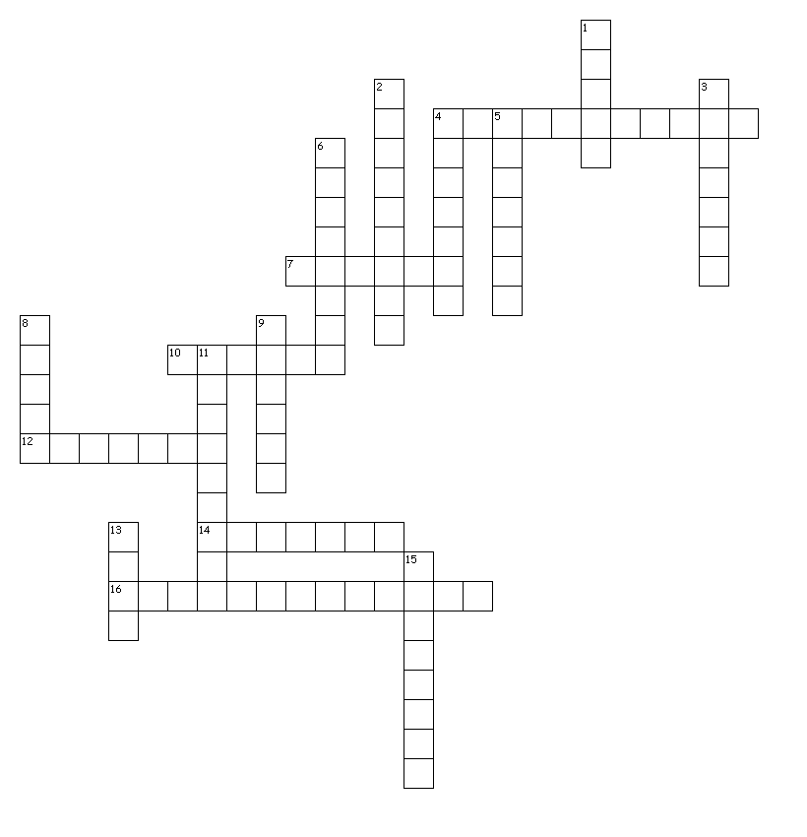

Across
4. воображение
7. писатель
10. известный
12. исследовать 16. расследование
14. необычный
Down
1. событие 8. преступление
2. персонаж 9. сплетня
3. путешествие 11. приключение
4. вдохновлять 13. тест, викторина
5. удивительный 15. обнаруживать
6. юмористический

