AGAINST ALL ODDS
SLIDE 1
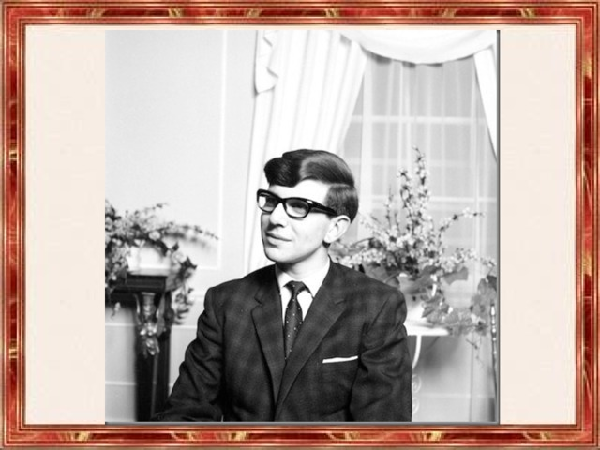
SLIDE 2
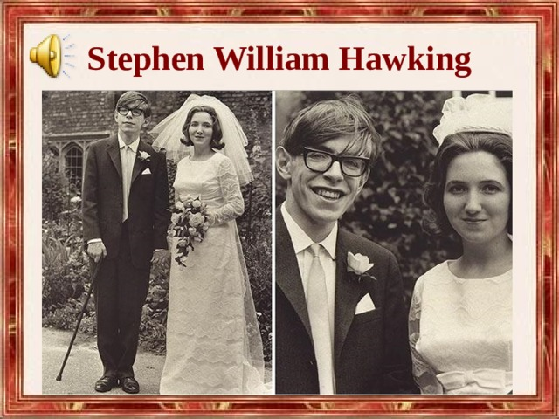
SLIDE 3
Mark the sentences T (true), F (false), DS (does not say). Correct the false sentences.
1 . Stephen William Hawking admires Jenny Smith.
2 . S.W. Hawking is a famous scientist.
3 . A computer system enables him to speak.
4 . He has got 4 children .
5 . He is the author of a bestseller.

SLIDE 4
Answer the questions

1.When and where was Stephen Hawking born?
2.Where did he study?
3.What subjects was he interested in?
4.What happened when he was at the university?
5.How did his disease go?
6.Can he speak now? How does he communicate?
7.What are his famous books?

SLIDE 5
Соотнеси слова из упр.2 с.30 с их определением
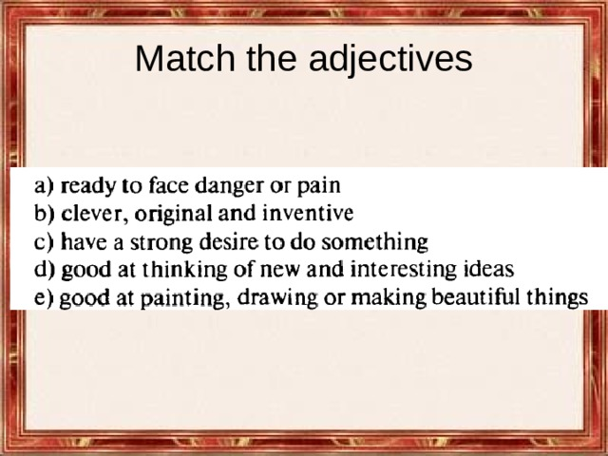

SLIDE 6
Find the following words in the text in SB, p. 30.
Восхищаться
Знаменит своей работой…
Справляться с
В конце концов
Делать возможным
Начать карьеру
Достигать
SLIDE 7
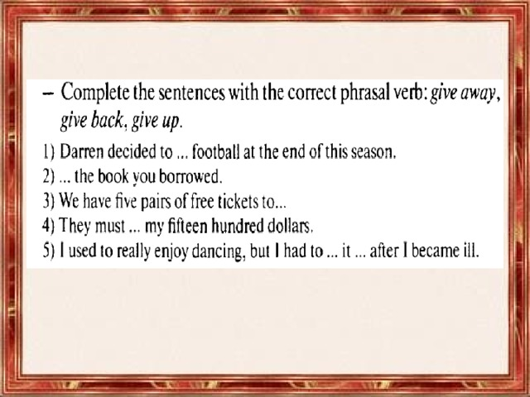
SLIDE 8